ZooKeeper 3

1 单机搭建环境 3

1.1 安装ant 3

1.2 导入操作 3

1.3 启动 4

2 伪集群搭建环境 7

3. 主要类介绍 13

3.1 QuorumPeerMain（单机和集群的启动类） 13

3.1.1 main方法 14

3.1.2 initializeAndRun方法 15

3.2 QuorumPeerConfig（配置解析类） 16

3.2.1 主要属性 16

3.2.2 parse方法 21

3.2.3 parseProperties方法 23

3.3 DatadirCleanupManager（快照数据清理任务管理器） 29

3.3.1 主要属性 29

3.3.2 start方法 30

3.4 ZooKeeperServerMain（单机启动） 30

3.4.1 主要属性 31

3.4.2 main方法 31

3.4.3 initializeAndRun 32

3.4.4 runFromConfig 33

3.4.5 shutdown 35

3.5 ZooKeeperServer （zk服务器） 36

3.5.1 属性 36

3.5.2 startdata 37

3.5.3 loadData 38

3.5.4 startup 启动 39

3.5.5 createSessionTracker 39

3.5.6 startSessionTracker 40

3.5.7 expire 40

3.5.8 submitRequest(提交请求) 41

3.5.9 setupRequestProcessors 42

3.6 ServerCnxnFactory 43

3.6.1 startup 43

3.7 NIOServerCnxnFactory（NIO） 44

3.7.1 startup(启动类) 44

3.7.2 start 45

3.8 NettyServerCnxnFactory 45

3.9 ZooKeeperThread (zk线程) 46

3.10 WorkerService(zk线程池) 46

3.11 SessionTrackerImpl(会话管理器，是个线程) 46

3.11.1 类结构 46

3.11.2 内部类 46

3.11.3 主要属性 47

3.11.4 SessionTrackerImpl的构造函数 48

3.11.5 run方法 50

3.12 ExpiryQueue(过期会话对列) 53

3.12.1 主要属性 53

3.13 ServerCnxn(服务端连接管理类) 53

3.13.1 属性 53

3.14 Watcher 55

3.15 RequestProcessor（请求处理器） 55

3.15.1 PreRequestProcessor(第一个处理器) 55

3.15.2 SyncRequestProcessor 55

3.15.3 FinalRequestProcessor(最后一个处理器) 55

# ZooKeeper

# 1 单机搭建环境

## 1.1 安装ant

下载地址：<https://ant.apache.org/bindownload.cgi>  
下载版本：1.10.7包：[apache-ant-1.10.7-bin.zip](http://mirror.bit.edu.cn/apache//ant/binaries/apache-ant-1.10.7-bin.zip) [ [PGP](https://www.apache.org/dist/ant/binaries/apache-ant-1.10.7-bin.zip.asc) ] [ [SHA512](https://www.apache.org/dist/ant/binaries/apache-ant-1.10.7-bin.zip.sha512) ]

解压，配置环境变量：

mac的配置

控制台：

vim ~/.bash_profile

添加ANT_HOME变量，将ANT_HOM加入到PATH中

export ANT_HOME=/Users/xxx/Documents/code_application/apache-ant-1.10.7

PATH=$PATH:$JAVA_HOME/bin:$PATH:$ANT_HOME/bin:

win：

解压，配置环境变量ANT_HOME=D:\apache-ant-1.10.7-bin\apache-ant-1.10.7  
编辑Path，增加%ANT_HOME%\bin

编辑classpath，增加%ANT_HOME%\lib

## 1.2 导入操作

1、下载zk源码： <https://github.com/apache/zookeeper>；版本：3.5.6

2、控制台切换到zk源码目录，执行

ant eclipse（正常要下载一会依赖，未出现异常）

1. 导入idea

导出过程中，要选Eclipse，不要选其他的，一路next

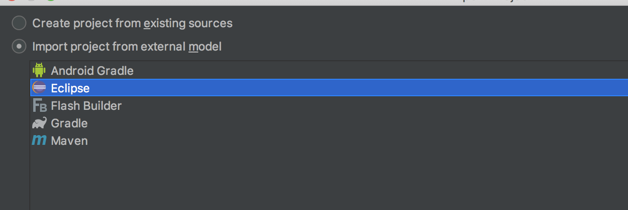

## 1.3 启动

1. 需要在org.apache.zookeeper.version包下面新建一个类(直接启动会包缺少这个类错误)

package org.apache.zookeeper.version;  
  
public interface Info {  
  
 int *MAJOR*=1;  
 int *MINOR*=0;  
 int *MICRO*=0;  
 String *QUALIFIER*=null;  
 int *REVISION*=-1; //*TODO: remove as related to SVN VCS* String *REVISION_HASH*="1";  
 String *BUILD_DATE*="2019-3-4";  
  
}

1. 启动ZooKeeperServerMain。会出现警告，需要配置

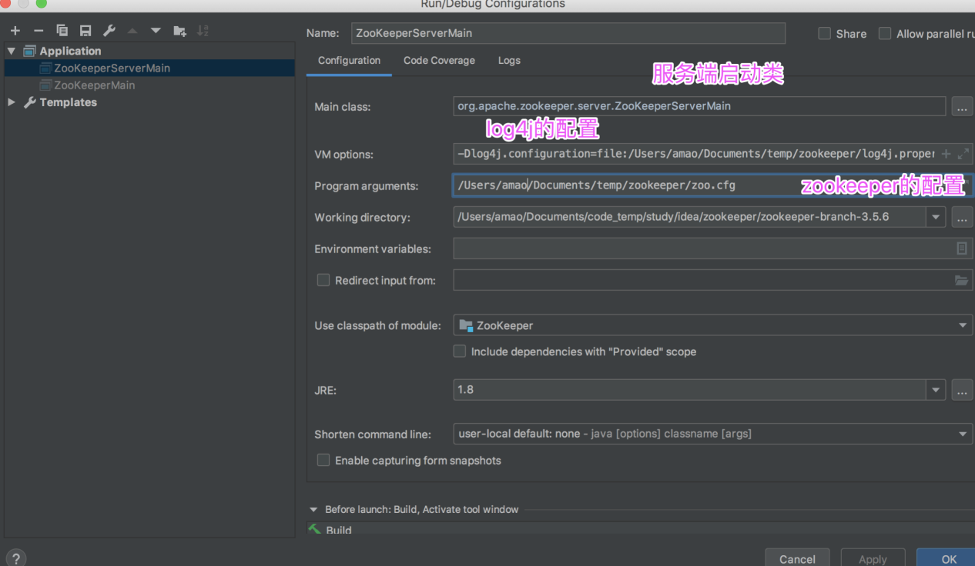

log4j.properties注意修改路径

|  |
| --- |
| log4j.rootLogger = debug,stdout,D,E  ### 输出信息到控制抬 ###  log4j.appender.stdout = org.apache.log4j.ConsoleAppender  log4j.appender.stdout.Target = System.out  log4j.appender.stdout.layout = org.apache.log4j.PatternLayout  log4j.appender.stdout.layout.ConversionPattern = [%-5p] %d{yyyy-MM-dd HH:mm:ss,SSS} method:%l%n%m%n  ### 输出DEBUG 级别以上的日志到=E://logs/error.log ###  log4j.appender.D = org.apache.log4j.DailyRollingFileAppender  log4j.appender.D.File = /Users/amao/Documents/temp/zookeeper/logs/log.log  log4j.appender.D.Append = true  log4j.appender.D.Threshold = DEBUG  log4j.appender.D.layout = org.apache.log4j.PatternLayout  log4j.appender.D.layout.ConversionPattern = %-d{yyyy-MM-dd HH:mm:ss} [ %t:%r ] - [ %p ] %m%n  ### 输出ERROR 级别以上的日志到=E://logs/error.log ###  log4j.appender.E = org.apache.log4j.DailyRollingFileAppender  log4j.appender.E.File =/Users/amao/Documents/temp/zookeeper/logs/error.log  log4j.appender.E.Append = true  log4j.appender.E.Threshold = ERROR  log4j.appender.E.layout = org.apache.log4j.PatternLayout  log4j.appender.E.layout.ConversionPattern = %-d{yyyy-MM-dd HH:mm:ss} [ %t:%r ] - [ %p ] %m%n |

zoo.cfg

|  |
| --- |
| # The number of milliseconds of each tick  tickTime=2000  # The number of ticks that the initial  # synchronization phase can take  initLimit=10  # The number of ticks that can pass between  # sending a request and getting an acknowledgement  syncLimit=5  # the directory where the snapshot is stored.  # do not use /tmp for storage, /tmp here is just  # example sakes.  dataDir=../data  # the port at which the clients will connect  clientPort=2181  # the maximum number of client connections.  # increase this if you need to handle more clients  #maxClientCnxns=60  #  # Be sure to read the maintenance section of the  # administrator guide before turning on autopurge.  #  # http://zookeeper.apache.org/doc/current/zookeeperAdmin.html#sc_maintenance  #  # The number of snapshots to retain in dataDir  #autopurge.snapRetainCount=3  # Purge task interval in hours  # Set to "0" to disable auto purge feature  #autopurge.purgeInterval=1 |

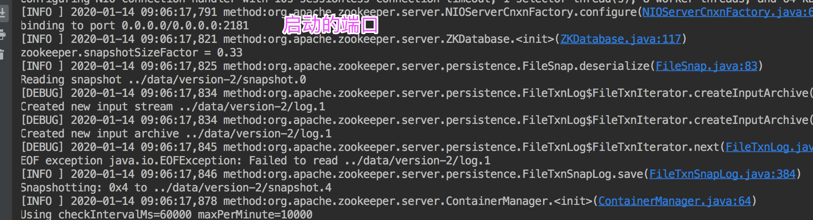

# 2 伪集群搭建环境

在导入idea中的有个bin目录，目录中有conf目录，该目录中log4j.properties和zoo_sample.cfg，confuguration.xsl 三个配置文件

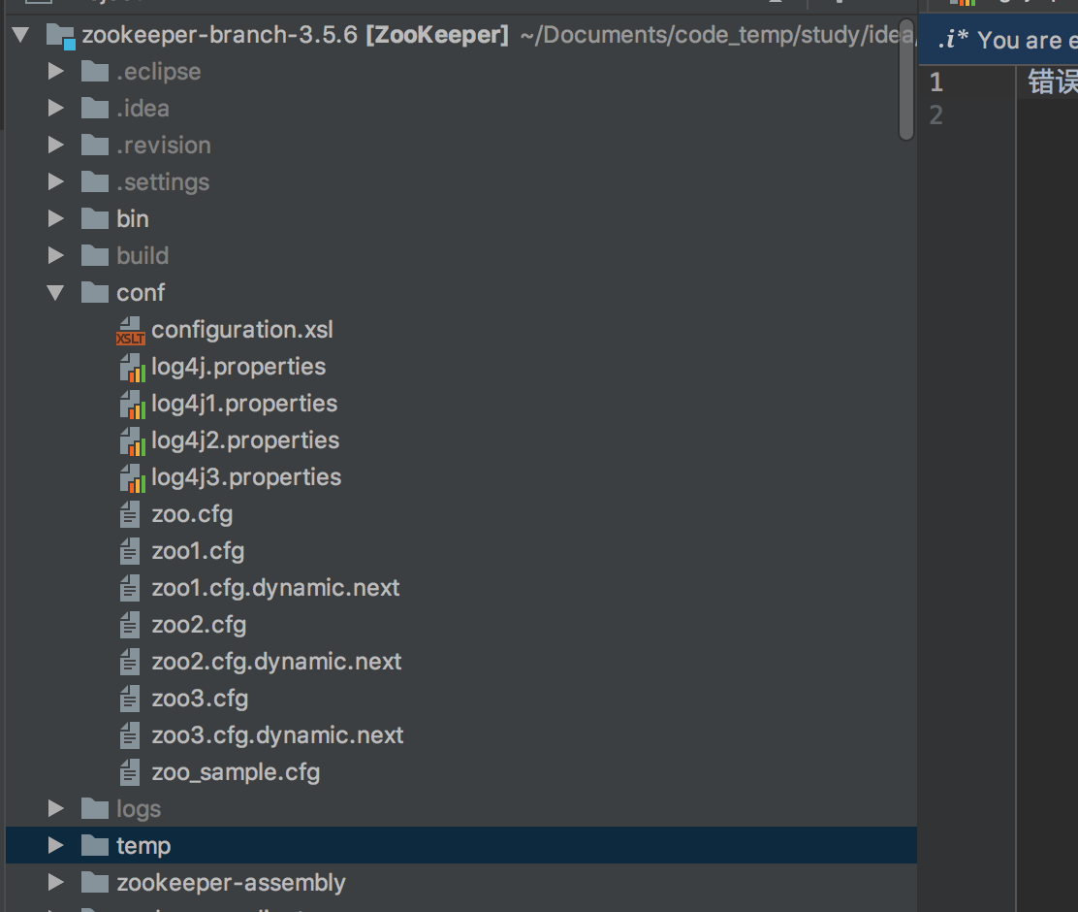

将log4j.properties和zoo_sample.cfg分别复制份，做如下配置

log4j.properties ,三个只有zookeeper.log.dir的值是三个文件夹，如下

/Users/amao/Documents/code_temp/study/idea/zookeeper/zookeeper-branch-3.4.14/logs/log1

/Users/amao/Documents/code_temp/study/idea/zookeeper/zookeeper-branch-3.4.14/logs/log2

/Users/amao/Documents/code_temp/study/idea/zookeeper/zookeeper-branch-3.4.14/logs/log3

|  |
| --- |
| # Copyright 2012 The Apache Software Foundation # # Licensed to the Apache Software Foundation (ASF) under one # or more contributor license agreements. See the NOTICE file # distributed with this work for additional information # regarding copyright ownership. The ASF licenses this file # to you under the Apache License, Version 2.0 (the # "License"); you may not use this file except in compliance # with the License. You may obtain a copy of the License at # # http://www.apache.org/licenses/LICENSE-2.0 # # Unless required by applicable law or agreed to in writing, software # distributed under the License is distributed on an "AS IS" BASIS, # WITHOUT WARRANTIES OR CONDITIONS OF ANY KIND, either express or implied. # See the License for the specific language governing permissions and # limitations under the License.  # Define some default values that can be overridden by system properties zookeeper.root.logger=DEBUG, CONSOLE, ROLLINGFILE  zookeeper.console.threshold=INFO  zookeeper.log.dir=/Users/amao/Documents/code_temp/study/idea/zookeeper/zookeeper-branch-3.4.14/logs/log1 zookeeper.log.file=zookeeper.log zookeeper.log.threshold=INFO zookeeper.log.maxfilesize=256MB zookeeper.log.maxbackupindex=20  zookeeper.tracelog.dir=${zookeeper.log.dir} zookeeper.tracelog.file=zookeeper_trace.log  log4j.rootLogger=${zookeeper.root.logger}  # # console # Add "console" to rootlogger above if you want to use this # log4j.appender.CONSOLE=org.apache.log4j.ConsoleAppender log4j.appender.CONSOLE.Threshold=${zookeeper.console.threshold} log4j.appender.CONSOLE.layout=org.apache.log4j.PatternLayout log4j.appender.CONSOLE.layout.ConversionPattern=%d{ISO8601} [myid:%X{myid}] - %-5p [%t:%C{1}@%L] - %m%n  # # Add ROLLINGFILE to rootLogger to get log file output # log4j.appender.ROLLINGFILE=org.apache.log4j.RollingFileAppender log4j.appender.ROLLINGFILE.Threshold=${zookeeper.log.threshold} log4j.appender.ROLLINGFILE.File=${zookeeper.log.dir}/${zookeeper.log.file} log4j.appender.ROLLINGFILE.MaxFileSize=${zookeeper.log.maxfilesize} log4j.appender.ROLLINGFILE.MaxBackupIndex=${zookeeper.log.maxbackupindex} log4j.appender.ROLLINGFILE.layout=org.apache.log4j.PatternLayout log4j.appender.ROLLINGFILE.layout.ConversionPattern=%d{ISO8601} [myid:%X{myid}] - %-5p [%t:%C{1}@%L] - %m%n  # # Add TRACEFILE to rootLogger to get log file output # Log TRACE level and above messages to a log file # log4j.appender.TRACEFILE=org.apache.log4j.FileAppender log4j.appender.TRACEFILE.Threshold=TRACE log4j.appender.TRACEFILE.File=${zookeeper.tracelog.dir}/${zookeeper.tracelog.file}  log4j.appender.TRACEFILE.layout=org.apache.log4j.PatternLayout ### Notice we are including log4j's NDC here (%x) log4j.appender.TRACEFILE.layout.ConversionPattern=%d{ISO8601} [myid:%X{myid}] - %-5p [%t:%C{1}@%L][%x] - %m%n |

zoo1.cfg

|  |
| --- |
| # The number of milliseconds of each tick tickTime=2000 # The number of ticks that the initial # synchronization phase can take initLimit=10 # The number of ticks that can pass between # sending a request and getting an acknowledgement syncLimit=5 # the directory where the snapshot is stored. # do not use /tmp for storage, /tmp here is just # example sakes. dataDir=/Users/amao/Documents/temp/zookeeper356/zk1 # the port at which the clients will connect  # 这个要注意每个不一样 clientPort=2181 # the maximum number of client connections. # increase this if you need to handle more clients #maxClientCnxns=60 # # Be sure to read the maintenance section of the # administrator guide before turning on autopurge. # # http://zookeeper.apache.org/doc/current/zookeeperAdmin.html#sc_maintenance # # The number of snapshots to retain in dataDir #autopurge.snapRetainCount=3 # Purge task interval in hours # Set to "0" to disable auto purge feature #autopurge.purgeInterval=1  # 这个要注意每个不一样 admin.serverPort=9091  server.1=127.0.0.1:2287:3387 server.2=127.0.0.1:2288:3388 server.3=127.0.0.1:2289:3389  zoo2.cfg  # The number of milliseconds of each tick tickTime=2000 # The number of ticks that the initial # synchronization phase can take initLimit=10 # The number of ticks that can pass between # sending a request and getting an acknowledgement syncLimit=5 # the directory where the snapshot is stored. # do not use /tmp for storage, /tmp here is just # example sakes. dataDir=/Users/amao/Documents/temp/zookeeper356/zk2 # the port at which the clients will connect clientPort=2182 # the maximum number of client connections. # increase this if you need to handle more clients #maxClientCnxns=60 # # Be sure to read the maintenance section of the # administrator guide before turning on autopurge. # # http://zookeeper.apache.org/doc/current/zookeeperAdmin.html#sc_maintenance # # The number of snapshots to retain in dataDir #autopurge.snapRetainCount=3 # Purge task interval in hours # Set to "0" to disable auto purge feature #autopurge.purgeInterval=1  admin.serverPort=9092  server.1=127.0.0.1:2287:3387 server.2=127.0.0.1:2288:3388 server.3=127.0.0.1:2289:3389  zoo3.cfg  # The number of milliseconds of each tick tickTime=2000 # The number of ticks that the initial # synchronization phase can take initLimit=10 # The number of ticks that can pass between # sending a request and getting an acknowledgement syncLimit=5 # the directory where the snapshot is stored. # do not use /tmp for storage, /tmp here is just # example sakes. dataDir=/Users/amao/Documents/temp/zookeeper356/zk3 # the port at which the clients will connect clientPort=2183 # the maximum number of client connections. # increase this if you need to handle more clients #maxClientCnxns=60 # # Be sure to read the maintenance section of the # administrator guide before turning on autopurge. # # http://zookeeper.apache.org/doc/current/zookeeperAdmin.html#sc_maintenance # # The number of snapshots to retain in dataDir #autopurge.snapRetainCount=3 # Purge task interval in hours # Set to "0" to disable auto purge feature #autopurge.purgeInterval=1  admin.serverPort=9093  server.1=127.0.0.1:2287:3387 server.2=127.0.0.1:2288:3388 server.3=127.0.0.1:2289:3389 |

分别org.apache.zookeeper.server.quorum.QuorumPeerMain复制三份，叫QuorumPeerMain1，QuorumPeerMain2，QuorumPeerMain3，这个三就是集群的启动类

启动类配置如下，配置启动的log4j和zoo.cfg，分别对应上述三个，正常启动第一个和第二个都会报错，知道第三个启动后，就都启动正常，我这边启动第二个的时候，QuorumPeerMain2就有LOOKING状态变为了LEADING，说明QuorumPeerMain2是leader，启动第三个的时候LOOKING状态变为了FOLLOWING，说明第三个是follower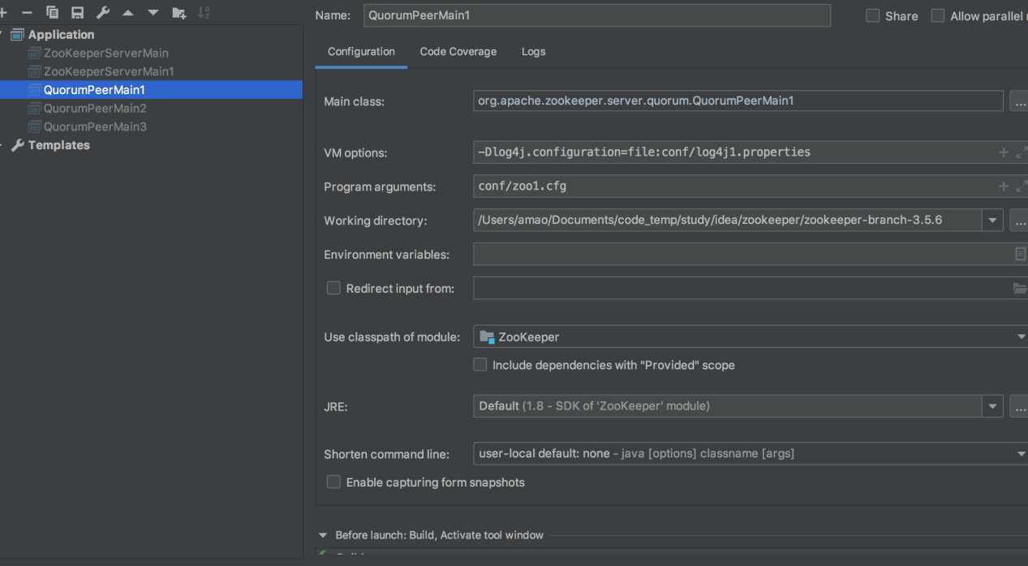

# 主要类介绍

## 3.1 QuorumPeerMain（单机和集群的启动类）

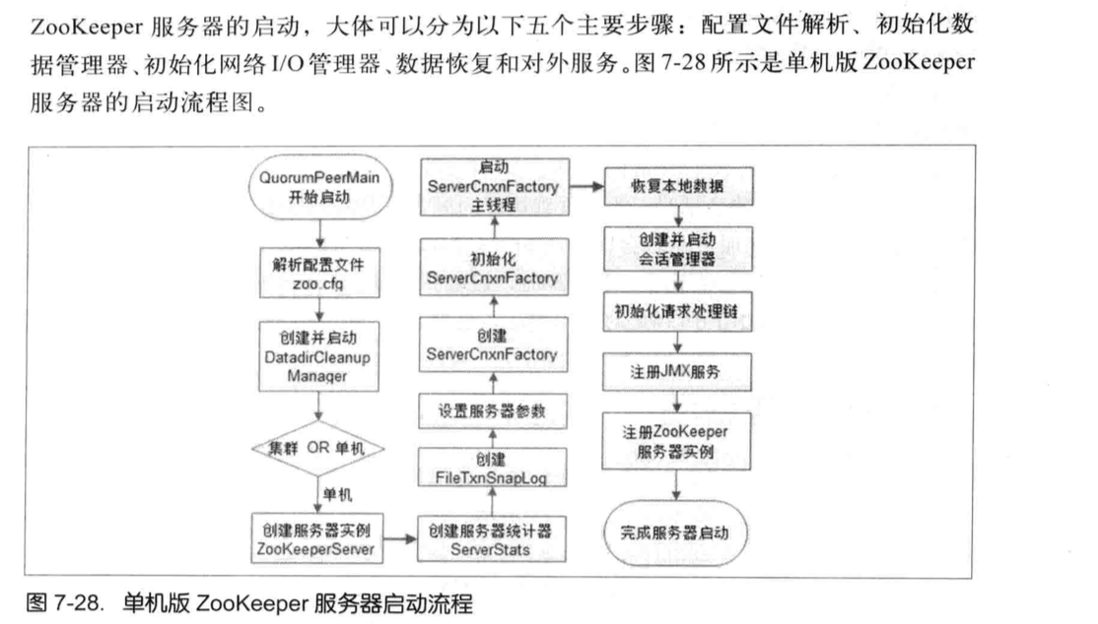

单机启动完成的工作

1. 配置文件解析
2. 初始化数据管理器
3. 初始化网络IO管理器
4. 数据恢复和对外服务

### 3.1.1 main方法

|  |
| --- |
| public static void main(String[] args) {  QuorumPeerMain main = new QuorumPeerMain();  try {  // 初始化和运行都是这个方法  main.initializeAndRun(args);  } catch (IllegalArgumentException e) {  *LOG*.error("Invalid arguments, exiting abnormally", e);  *LOG*.info(*USAGE*);  System.*err*.println(*USAGE*);  System.*exit*(2);  } catch (ConfigException e) {  *LOG*.error("Invalid config, exiting abnormally", e);  System.*err*.println("Invalid config, exiting abnormally");  System.*exit*(2);  } catch (DatadirException e) {  *LOG*.error("Unable to access datadir, exiting abnormally", e);  System.*err*.println("Unable to access datadir, exiting abnormally");  System.*exit*(3);  } catch (AdminServerException e) {  *LOG*.error("Unable to start AdminServer, exiting abnormally", e);  System.*err*.println("Unable to start AdminServer, exiting abnormally");  System.*exit*(4);  } catch (Exception e) {  *LOG*.error("Unexpected exception, exiting abnormally", e);  System.*exit*(1);  }  *LOG*.info("Exiting normally");  System.*exit*(0); } |

### 3.1.2 initializeAndRun方法

1. 完成zoo.cfg的配置解析工作，主要是QuorumPeerConfig完成
2. 创建一个DatadirClearupManager管理器，主要启动一个定时器，执行定时清理数据快照等文件的任务。这个
3. 判断是集群启动还是单集启动，集群走runFromConfig，单机直接启动ZooKeeperServerMain

分析单机启动先

|  |
| --- |
| protected void initializeAndRun(String[] args)  throws ConfigException, IOException, AdminServerException {  // 解析配置文件  QuorumPeerConfig config = new QuorumPeerConfig();  if (args.length == 1) {  config.parse(args[0]);  }   // Start and schedule the the purge task  // 启动一个定时清理快照数据的任务  DatadirCleanupManager purgeMgr = new DatadirCleanupManager(config  .getDataDir(), config.getDataLogDir(), config  .getSnapRetainCount(), config.getPurgeInterval());  purgeMgr.start();   if (args.length == 1 && config.isDistributed()) {  // 集群的启动  runFromConfig(config);  } else {  *LOG*.warn("Either no config or no quorum defined in config, running "  + " in standalone mode");  // there is only server in the quorum -- run as standalone  // 单机启动  ZooKeeperServerMain.*main*(args);  } } |

## 3.2 QuorumPeerConfig（配置解析类）

这个类组要为了完成解析zoo.cfg文件的

### 3.2.1 主要属性

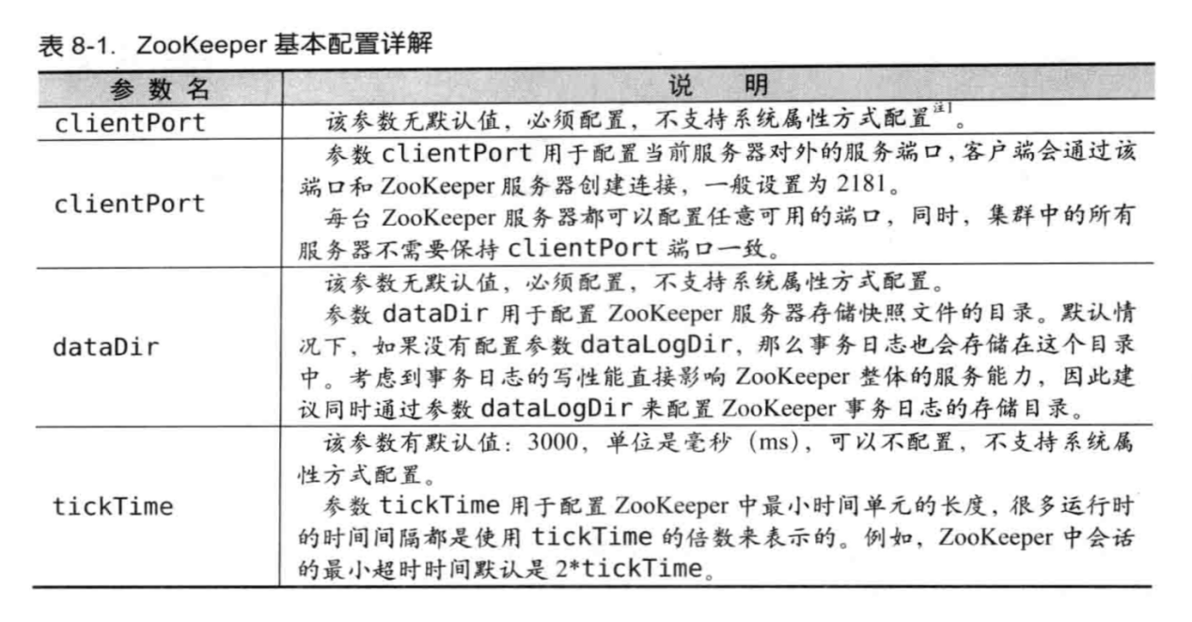

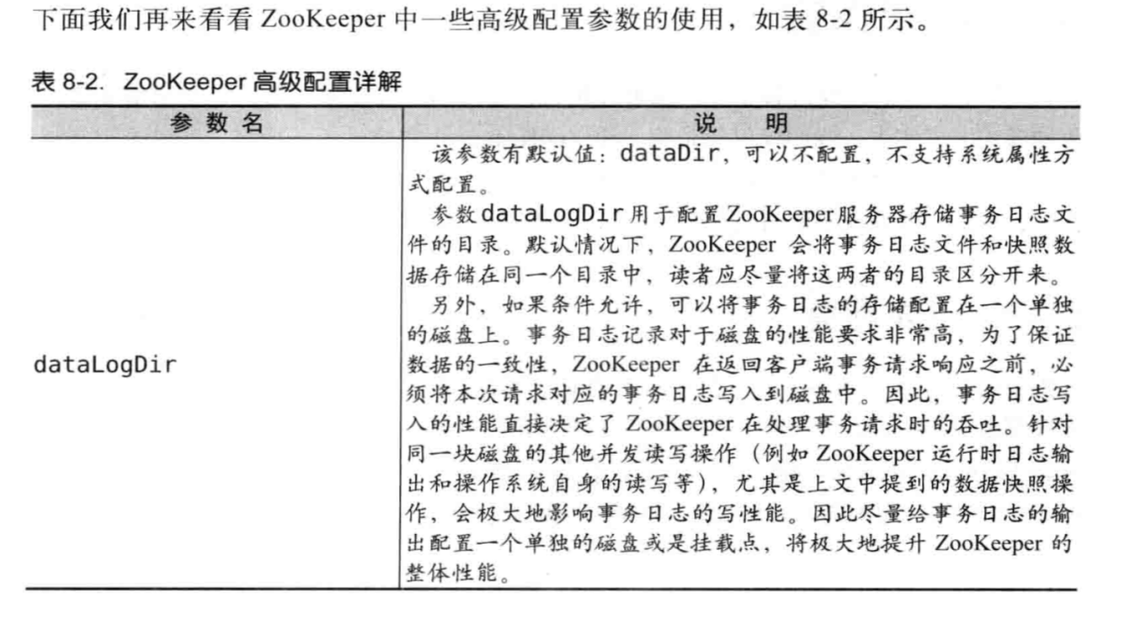

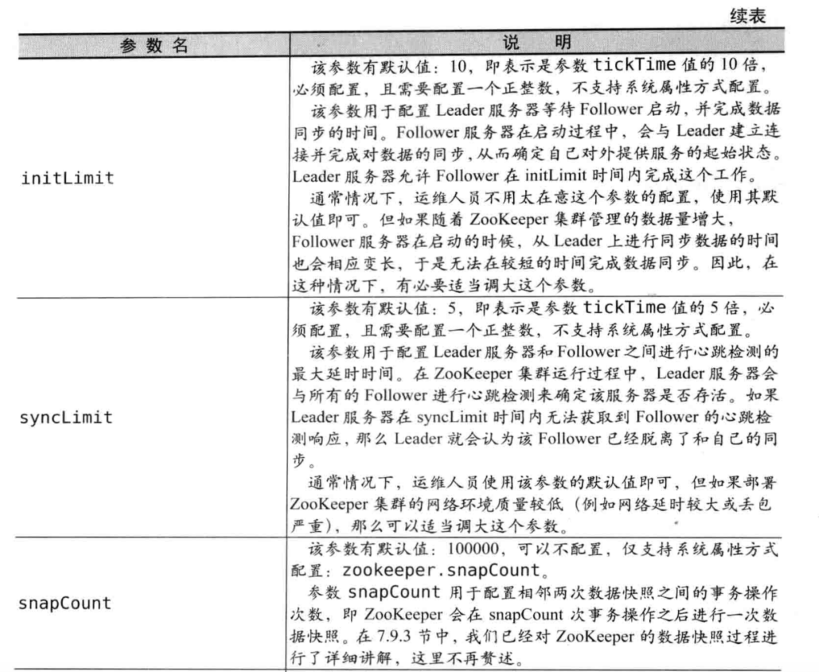

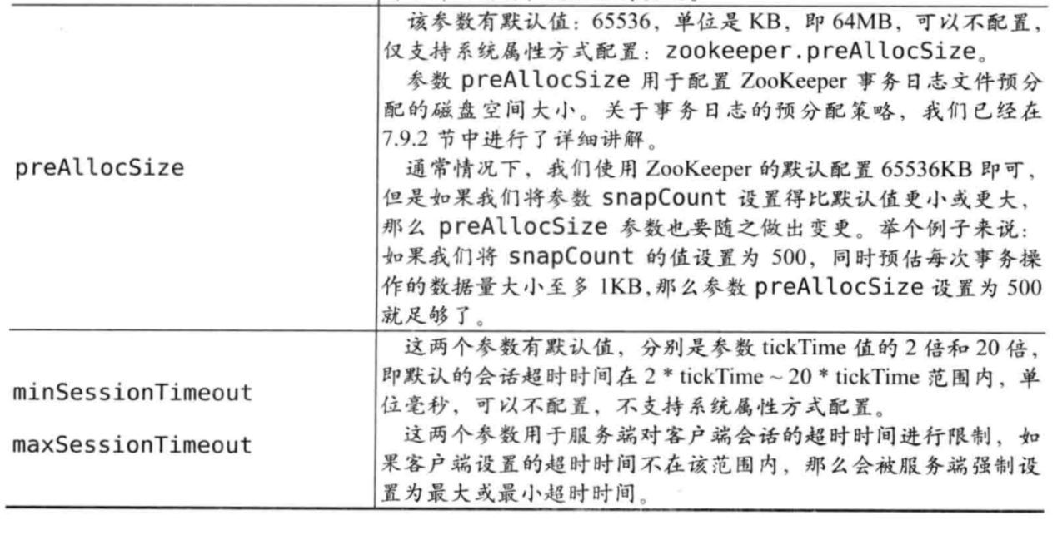

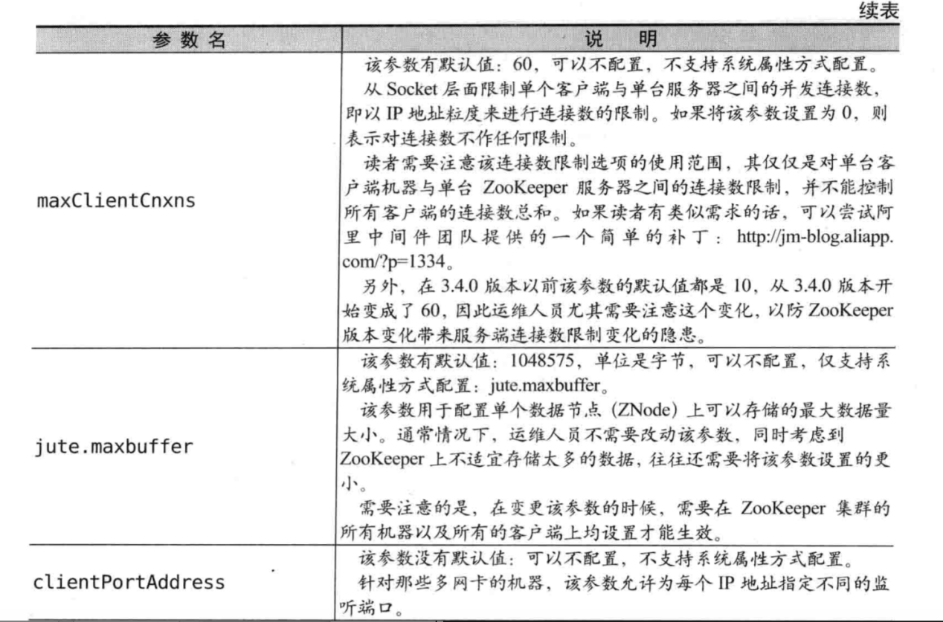

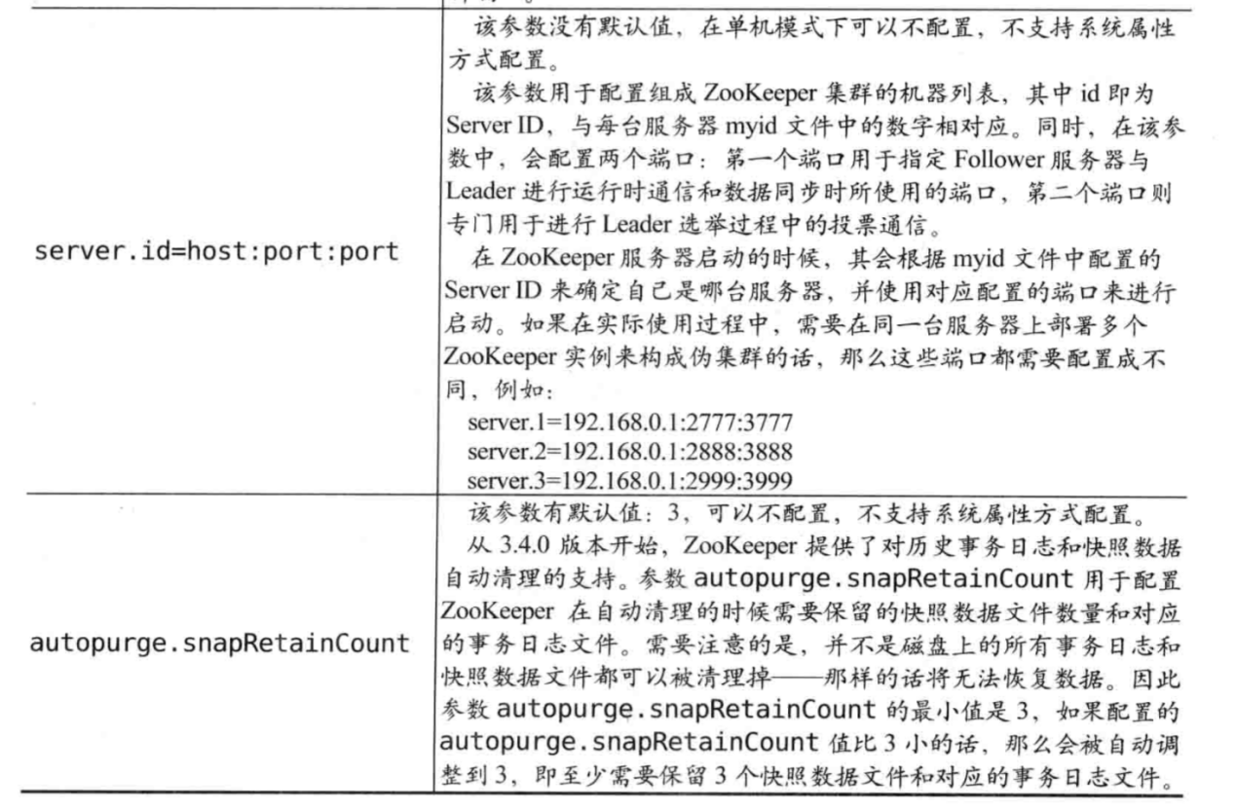

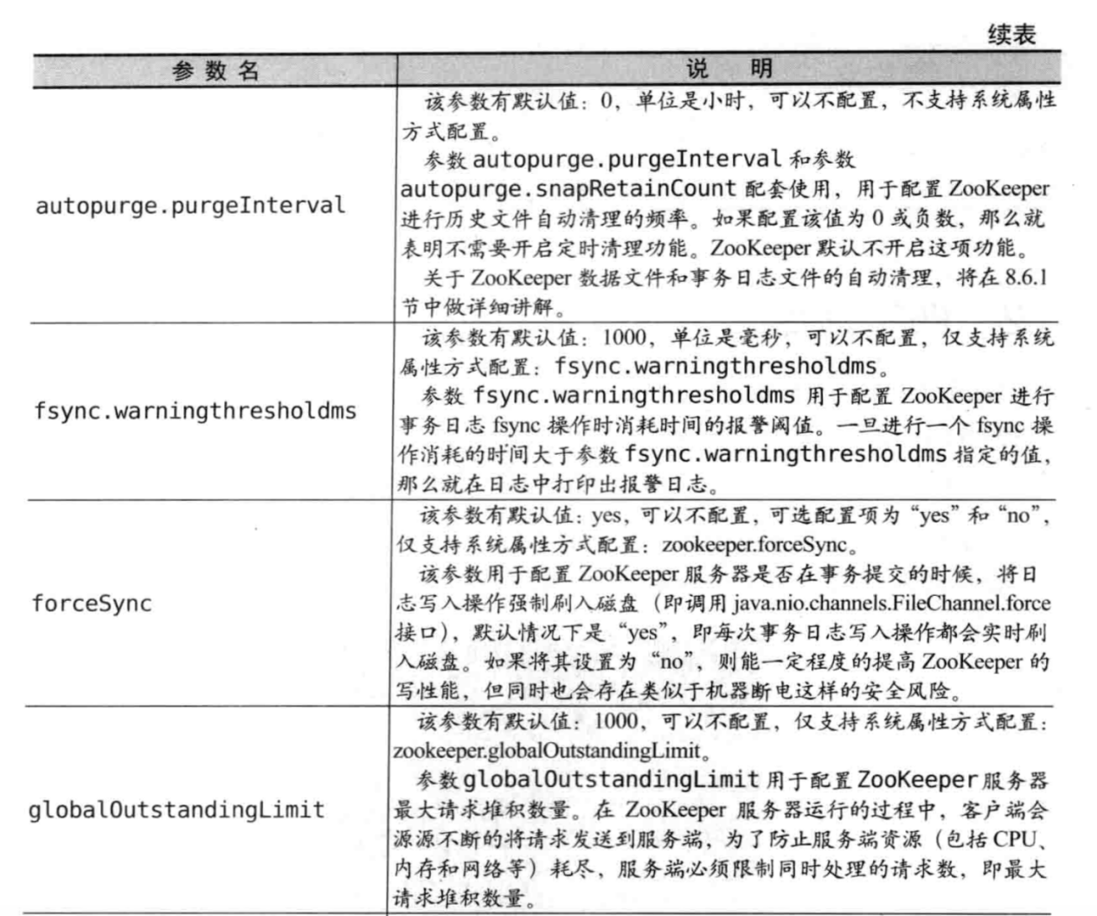

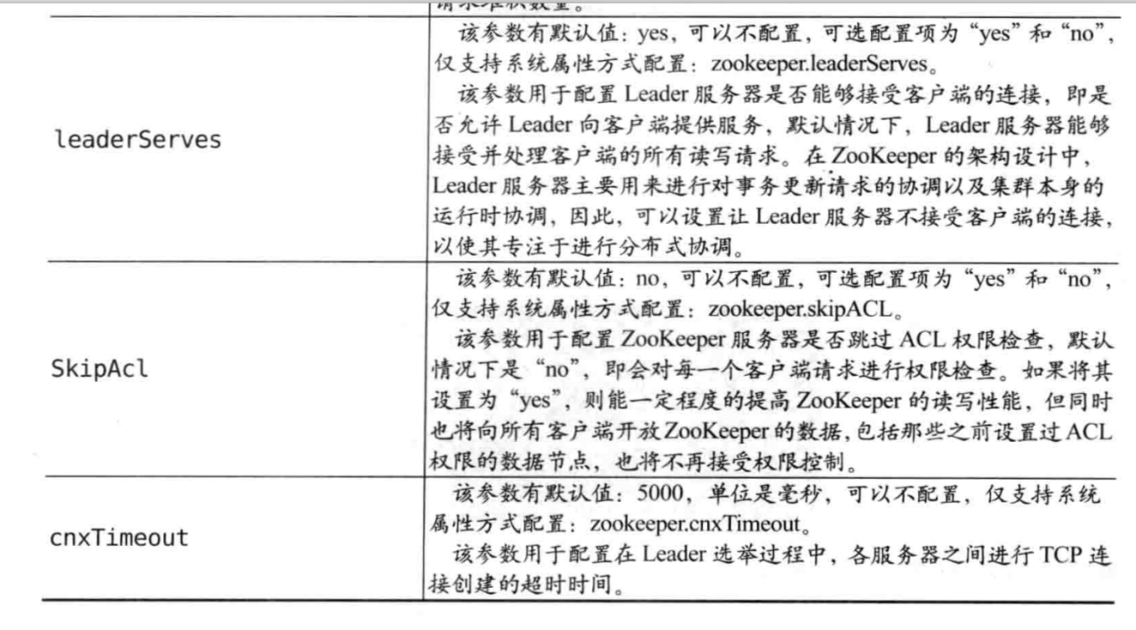

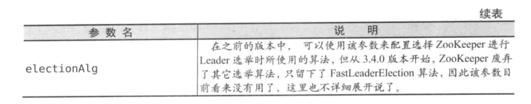

|  |
| --- |
| private static final int *UNSET_SERVERID* = -1; public static final String *nextDynamicConfigFileSuffix* = ".dynamic.next";  private static boolean *standaloneEnabled* = true; private static boolean *reconfigEnabled* = false;  protected InetSocketAddress clientPortAddress; protected InetSocketAddress secureClientPortAddress; protected boolean sslQuorum = false; protected boolean shouldUsePortUnification = false; protected boolean sslQuorumReloadCertFiles = false;  // 必须配置，存储快照文件的目录。如果没有配置dataLogDir的话，事务日志夜壶存  // 储在这个目录中 protected File dataDir;  // 事务日志存储的目录 protected File dataLogDir;  protected String dynamicConfigFileStr = null; protected String configFileStr = null;  // 3000,单位是毫秒(ms)，可以不配置，不支持系统属性 protected int tickTime = ZooKeeperServer.*DEFAULT_TICK_TIME*; // 从Socket层面  protected int maxClientCnxns = 60; */** defaults to -1 if not set explicitly */* protected int minSessionTimeout = -1; */** defaults to -1 if not set explicitly */* protected int maxSessionTimeout = -1; protected boolean localSessionsEnabled = false; protected boolean localSessionsUpgradingEnabled = false; // 必须配置，Leader服务器等待Follower启动，并完成数据同步的时间。 protected int initLimit;  // 必须配置，Leader服务和Follower之间进行心跳检测的最大延时时间。 protected int syncLimit;  // 进行Leader选举时锁使用的算法。 protected int electionAlg = 3;  //  protected int electionPort = 2182; protected boolean quorumListenOnAllIPs = false;  protected long serverId = *UNSET_SERVERID*;  protected QuorumVerifier quorumVerifier = null, lastSeenQuorumVerifier = null; protected int snapRetainCount = 3;  // 和snapRetainCount配套使用，用于配置ZooKeeper进行历史文件自动清理的频// 率,如果配置该值为0或负数，那么就表名不需要开启定时清理功能。 protected int purgeInterval = 0; protected boolean syncEnabled = true;  protected LearnerType peerType = LearnerType.*PARTICIPANT*;  */**  * Configurations for the quorumpeer-to-quorumpeer sasl authentication  */* protected boolean quorumServerRequireSasl = false; protected boolean quorumLearnerRequireSasl = false; protected boolean quorumEnableSasl = false; protected String quorumServicePrincipal = QuorumAuth.*QUORUM_KERBEROS_SERVICE_PRINCIPAL_DEFAULT_VALUE*; protected String quorumLearnerLoginContext = QuorumAuth.*QUORUM_LEARNER_SASL_LOGIN_CONTEXT_DFAULT_VALUE*; protected String quorumServerLoginContext = QuorumAuth.*QUORUM_SERVER_SASL_LOGIN_CONTEXT_DFAULT_VALUE*; protected int quorumCnxnThreadsSize; |

### 3.2.2 parse方法

|  |
| --- |
| public void parse(String path) throws ConfigException {  *LOG*.info("Reading configuration from: " + path);    try {  // 获得到配置文件对象  File configFile = (new VerifyingFileFactory.Builder(*LOG*)  .warnForRelativePath()  .failForNonExistingPath()  .build()).create(path);    Properties cfg = new Properties();  FileInputStream in = new FileInputStream(configFile);  try {  // 加载  cfg.load(in);  configFileStr = path;  } finally {  in.close();  }  // 解析属性，这个方法中纯粹是解析赋值操作,可以查看parse  parseProperties(cfg);  } catch (IOException e) {  throw new ConfigException("Error processing " + path, e);  } catch (IllegalArgumentException e) {  throw new ConfigException("Error processing " + path, e);  }  // 动态配置文件解析  if (dynamicConfigFileStr!=null) {  try {   Properties dynamicCfg = new Properties();  FileInputStream inConfig = new FileInputStream(dynamicConfigFileStr);  try {  dynamicCfg.load(inConfig);  if (dynamicCfg.getProperty("version") != null) {  throw new ConfigException("dynamic file shouldn't have version inside");  }   String version = *getVersionFromFilename*(dynamicConfigFileStr);  // If there isn't any version associated with the filename,  // the default version is 0.  if (version != null) {  dynamicCfg.setProperty("version", version);  }  } finally {  inConfig.close();  }  setupQuorumPeerConfig(dynamicCfg, false);   } catch (IOException e) {  throw new ConfigException("Error processing " + dynamicConfigFileStr, e);  } catch (IllegalArgumentException e) {  throw new ConfigException("Error processing " + dynamicConfigFileStr, e);  }   File nextDynamicConfigFile = new File(configFileStr + *nextDynamicConfigFileSuffix*);  if (nextDynamicConfigFile.exists()) {  try {   Properties dynamicConfigNextCfg = new Properties();  FileInputStream inConfigNext = new FileInputStream(nextDynamicConfigFile);   try {  dynamicConfigNextCfg.load(inConfigNext);  } finally {  inConfigNext.close();  }  boolean isHierarchical = false;  for (Entry<Object, Object> entry : dynamicConfigNextCfg.entrySet()) {  String key = entry.getKey().toString().trim();   if (key.startsWith("group") || key.startsWith("weight")) {  isHierarchical = true;  break;  }  }  lastSeenQuorumVerifier = *createQuorumVerifier*(dynamicConfigNextCfg, isHierarchical);  } catch (IOException e) {  *LOG*.warn("NextQuorumVerifier is initiated to null");  }  }  } } |

### 3.2.3 parseProperties方法

|  |
| --- |
| public void parseProperties(Properties zkProp) throws IOException, ConfigException {  int clientPort = 0;  int secureClientPort = 0;  String clientPortAddress = null;  String secureClientPortAddress = null;  VerifyingFileFactory vff = new VerifyingFileFactory.Builder(*LOG*).warnForRelativePath().build();  for (Entry<Object, Object> entry : zkProp.entrySet()) {  String key = entry.getKey().toString().trim();  String value = entry.getValue().toString().trim();  if (key.equals("dataDir")) {  dataDir = vff.create(value);  } else if (key.equals("dataLogDir")) {  dataLogDir = vff.create(value);  } else if (key.equals("clientPort")) {  clientPort = Integer.*parseInt*(value);  } else if (key.equals("localSessionsEnabled")) {  localSessionsEnabled = Boolean.*parseBoolean*(value);  } else if (key.equals("localSessionsUpgradingEnabled")) {  localSessionsUpgradingEnabled = Boolean.*parseBoolean*(value);  } else if (key.equals("clientPortAddress")) {  clientPortAddress = value.trim();  } else if (key.equals("secureClientPort")) {  secureClientPort = Integer.*parseInt*(value);  } else if (key.equals("secureClientPortAddress")){  secureClientPortAddress = value.trim();  } else if (key.equals("tickTime")) {  tickTime = Integer.*parseInt*(value);  } else if (key.equals("maxClientCnxns")) {  maxClientCnxns = Integer.*parseInt*(value);  } else if (key.equals("minSessionTimeout")) {  minSessionTimeout = Integer.*parseInt*(value);  } else if (key.equals("maxSessionTimeout")) {  maxSessionTimeout = Integer.*parseInt*(value);  } else if (key.equals("initLimit")) {  initLimit = Integer.*parseInt*(value);  } else if (key.equals("syncLimit")) {  syncLimit = Integer.*parseInt*(value);  } else if (key.equals("electionAlg")) {  electionAlg = Integer.*parseInt*(value);  } else if (key.equals("quorumListenOnAllIPs")) {  quorumListenOnAllIPs = Boolean.*parseBoolean*(value);  } else if (key.equals("peerType")) {  if (value.toLowerCase().equals("observer")) {  peerType = LearnerType.*OBSERVER*;  } else if (value.toLowerCase().equals("participant")) {  peerType = LearnerType.*PARTICIPANT*;  } else  {  throw new ConfigException("Unrecognised peertype: " + value);  }  } else if (key.equals( "syncEnabled" )) {  syncEnabled = Boolean.*parseBoolean*(value);  } else if (key.equals("dynamicConfigFile")){  dynamicConfigFileStr = value;  } else if (key.equals("autopurge.snapRetainCount")) {  snapRetainCount = Integer.*parseInt*(value);  } else if (key.equals("autopurge.purgeInterval")) {  purgeInterval = Integer.*parseInt*(value);  } else if (key.equals("standaloneEnabled")) {  if (value.toLowerCase().equals("true")) {  *setStandaloneEnabled*(true);  } else if (value.toLowerCase().equals("false")) {  *setStandaloneEnabled*(false);  } else {  throw new ConfigException("Invalid option " + value + " for standalone mode. Choose 'true' or 'false.'");  }  } else if (key.equals("reconfigEnabled")) {  if (value.toLowerCase().equals("true")) {  *setReconfigEnabled*(true);  } else if (value.toLowerCase().equals("false")) {  *setReconfigEnabled*(false);  } else {  throw new ConfigException("Invalid option " + value + " for reconfigEnabled flag. Choose 'true' or 'false.'");  }  } else if (key.equals("sslQuorum")){  sslQuorum = Boolean.*parseBoolean*(value);  } else if (key.equals("portUnification")){  shouldUsePortUnification = Boolean.*parseBoolean*(value);  } else if (key.equals("sslQuorumReloadCertFiles")) {  sslQuorumReloadCertFiles = Boolean.*parseBoolean*(value);  } else if ((key.startsWith("server.") || key.startsWith("group") || key.startsWith("weight")) && zkProp.containsKey("dynamicConfigFile")) {  throw new ConfigException("parameter: " + key + " must be in a separate dynamic config file");  } else if (key.equals(QuorumAuth.*QUORUM_SASL_AUTH_ENABLED*)) {  quorumEnableSasl = Boolean.*parseBoolean*(value);  } else if (key.equals(QuorumAuth.*QUORUM_SERVER_SASL_AUTH_REQUIRED*)) {  quorumServerRequireSasl = Boolean.*parseBoolean*(value);  } else if (key.equals(QuorumAuth.*QUORUM_LEARNER_SASL_AUTH_REQUIRED*)) {  quorumLearnerRequireSasl = Boolean.*parseBoolean*(value);  } else if (key.equals(QuorumAuth.*QUORUM_LEARNER_SASL_LOGIN_CONTEXT*)) {  quorumLearnerLoginContext = value;  } else if (key.equals(QuorumAuth.*QUORUM_SERVER_SASL_LOGIN_CONTEXT*)) {  quorumServerLoginContext = value;  } else if (key.equals(QuorumAuth.*QUORUM_KERBEROS_SERVICE_PRINCIPAL*)) {  quorumServicePrincipal = value;  } else if (key.equals("quorum.cnxn.threads.size")) {  quorumCnxnThreadsSize = Integer.*parseInt*(value);  } else {  System.*setProperty*("zookeeper." + key, value);  }  }   if (!quorumEnableSasl && quorumServerRequireSasl) {  throw new IllegalArgumentException(  QuorumAuth.*QUORUM_SASL_AUTH_ENABLED* + " is disabled, so cannot enable "  + QuorumAuth.*QUORUM_SERVER_SASL_AUTH_REQUIRED*);  }  if (!quorumEnableSasl && quorumLearnerRequireSasl) {  throw new IllegalArgumentException(  QuorumAuth.*QUORUM_SASL_AUTH_ENABLED* + " is disabled, so cannot enable "  + QuorumAuth.*QUORUM_LEARNER_SASL_AUTH_REQUIRED*);  }  // If quorumpeer learner is not auth enabled then self won't be able to  // join quorum. So this condition is ensuring that the quorumpeer learner  // is also auth enabled while enabling quorum server require sasl.  if (!quorumLearnerRequireSasl && quorumServerRequireSasl) {  throw new IllegalArgumentException(  QuorumAuth.*QUORUM_LEARNER_SASL_AUTH_REQUIRED* + " is disabled, so cannot enable "  + QuorumAuth.*QUORUM_SERVER_SASL_AUTH_REQUIRED*);  }   // Reset to MIN_SNAP_RETAIN_COUNT if invalid (less than 3)  // PurgeTxnLog.purge(File, File, int) will not allow to purge less  // than 3.  if (snapRetainCount < MIN_SNAP_RETAIN_COUNT) {  *LOG*.warn("Invalid autopurge.snapRetainCount: " + snapRetainCount  + ". Defaulting to " + MIN_SNAP_RETAIN_COUNT);  snapRetainCount = MIN_SNAP_RETAIN_COUNT;  }   if (dataDir == null) {  throw new IllegalArgumentException("dataDir is not set");  }  if (dataLogDir == null) {  dataLogDir = dataDir;  }   if (clientPort == 0) {  *LOG*.info("clientPort is not set");  if (clientPortAddress != null) {  throw new IllegalArgumentException("clientPortAddress is set but clientPort is not set");  }  } else if (clientPortAddress != null) {  this.clientPortAddress = new InetSocketAddress(  InetAddress.*getByName*(clientPortAddress), clientPort);  *LOG*.info("clientPortAddress is {}", this.clientPortAddress.toString());  } else {  this.clientPortAddress = new InetSocketAddress(clientPort);  *LOG*.info("clientPortAddress is {}", this.clientPortAddress.toString());  }   if (secureClientPort == 0) {  *LOG*.info("secureClientPort is not set");  if (secureClientPortAddress != null) {  throw new IllegalArgumentException("secureClientPortAddress is set but secureClientPort is not set");  }  } else if (secureClientPortAddress != null) {  this.secureClientPortAddress = new InetSocketAddress(  InetAddress.*getByName*(secureClientPortAddress), secureClientPort);  *LOG*.info("secureClientPortAddress is {}", this.secureClientPortAddress.toString());  } else {  this.secureClientPortAddress = new InetSocketAddress(secureClientPort);  *LOG*.info("secureClientPortAddress is {}", this.secureClientPortAddress.toString());  }  if (this.secureClientPortAddress != null) {  configureSSLAuth();  }   if (tickTime == 0) {  throw new IllegalArgumentException("tickTime is not set");  }   minSessionTimeout = minSessionTimeout == -1 ? tickTime * 2 : minSessionTimeout;  maxSessionTimeout = maxSessionTimeout == -1 ? tickTime * 20 : maxSessionTimeout;   if (minSessionTimeout > maxSessionTimeout) {  throw new IllegalArgumentException(  "minSessionTimeout must not be larger than maxSessionTimeout");  }    // backward compatibility - dynamic configuration in the same file as  // static configuration params see writeDynamicConfig()  if (dynamicConfigFileStr == null) {  setupQuorumPeerConfig(zkProp, true);  if (isDistributed() && *isReconfigEnabled*()) {  // we don't backup static config for standalone mode.  // we also don't backup if reconfig feature is disabled.  backupOldConfig();  }  } } |

## 3.3 DatadirCleanupManager（快照数据清理任务管理器）

### 3.3.1 主要属性

|  |
| --- |
| // 清理状态，未启动，启动，完成  public enum PurgeTaskStatus {  *NOT_STARTED*, *STARTED*, *COMPLETED*; }  // 默认状态是为启动 private PurgeTaskStatus purgeTaskStatus = PurgeTaskStatus.*NOT_STARTED*;  // 快照数据目录 private final File snapDir;  // 事务日志目录 private final File dataLogDir;  // 清理之后保留的快照文件的数量  // 即快照数据保持一定的数量，超过这个数量，就会被清理掉 private final int snapRetainCount;  // 定时清理的时间 private final int purgeInterval;  // 定时器 private Timer timer; |

### 3.3.2 start方法

启动定时清理的任务

|  |
| --- |
| public void start() {  // 判断状态是否已经启动  if (PurgeTaskStatus.*STARTED* == purgeTaskStatus) {  *LOG*.warn("Purge task is already running.");  return;  }  // Don't schedule the purge task with zero or negative purge interval.  // 定时清理的时间要大于0  if (purgeInterval <= 0) {  *LOG*.info("Purge task is not scheduled.");  return;  }  // 创建定时器  timer = new Timer("PurgeTask", true);  // 创建任务  // PurgeTask是TimeTask的子类，实际是个Runnable  // 最终执行PurgeTask的run方法  TimerTask task = new PurgeTask(dataLogDir, snapDir, snapRetainCount);  // 提交任务，执行定时清理的  timer.scheduleAtFixedRate(task, 0, TimeUnit.*HOURS*.toMillis(purgeInterval));   purgeTaskStatus = PurgeTaskStatus.*STARTED*; } |

## 3.4 ZooKeeperServerMain（单机启动）

其实，单机启动这个类就可以启动

### 3.4.1 主要属性

|  |
| --- |
| // 服务端连接工厂，有两个实现，基于NIO和基于netty的实现  // 可通过zookeeper.serverCnxnFactory来设置类名  // 没有设置默认是使用NIOServerCnxnFactory  private ServerCnxnFactory cnxnFactory;  // 安全连接工厂 private ServerCnxnFactory secureCnxnFactory;  // 数据节点的清理容器：仅运行在leader服务器，followers/observers运行产生// 没必要的额外开销,也就是followers/observers可以运行，只是没必要。 private ContainerManager containerManager; // 猜测是命令行操作的连接服务器：有两个实现，一个是个“空”server，另一个是个  // jetty实现的服务器 private AdminServer adminServer; |

### 3.4.2 main方法

调用初始化和运行的方法

|  |
| --- |
| public static void main(String[] args) {  ZooKeeperServerMain main = new ZooKeeperServerMain();  try {  main.initializeAndRun(args);  } catch (IllegalArgumentException e) {  *LOG*.error("Invalid arguments, exiting abnormally", e);  *LOG*.info(*USAGE*);  System.*err*.println(*USAGE*);  System.*exit*(2);  } catch (ConfigException e) {  *LOG*.error("Invalid config, exiting abnormally", e);  System.*err*.println("Invalid config, exiting abnormally");  System.*exit*(2);  } catch (DatadirException e) {  *LOG*.error("Unable to access datadir, exiting abnormally", e);  System.*err*.println("Unable to access datadir, exiting abnormally");  System.*exit*(3);  } catch (AdminServerException e) {  *LOG*.error("Unable to start AdminServer, exiting abnormally", e);  System.*err*.println("Unable to start AdminServer, exiting abnormally");  System.*exit*(4);  } catch (Exception e) {  *LOG*.error("Unexpected exception, exiting abnormally", e);  System.*exit*(1);  }  *LOG*.info("Exiting normally");  System.*exit*(0); } |

### 3.4.3 initializeAndRun

|  |
| --- |
| protected void initializeAndRun(String[] args)  throws ConfigException, IOException, AdminServerException {  try {  // 注册log4j的bean，先不用管，猜测是设置日志输出用的，和日志配置有关  ManagedUtil.*registerLog4jMBeans*();  } catch (JMException e) {  *LOG*.warn("Unable to register log4j JMX control", e);  }  // 配置文件解析类，这个和QuorumPeerConfig类似，不过比它少了很多属性  // 只有几个重要的属性，也有解析的方法  ServerConfig config = new ServerConfig();   if (args.length == 1) {  config.parse(args[0]);  } else {  config.parse(args);  }  // 根据配置文件开始启动相关组件  runFromConfig(config); } |

### 3.4.4 runFromConfig

整个方法均是初始化相关组件和启动组件

|  |
| --- |
| public void runFromConfig(ServerConfig config)  throws IOException, AdminServerException {  *LOG*.info("Starting server");  FileTxnSnapLog txnLog = null;  try {  // Note that this thread isn't going to be doing anything else,  // so rather than spawning another thread, we will just call  // run() in this thread.  // create a file logger url from the command line args  // 创建事务日志和快照的管理的类  txnLog = new FileTxnSnapLog(config.dataLogDir, config.dataDir);  // 创建zookeeperServer  final ZooKeeperServer zkServer = new ZooKeeperServer(txnLog,  config.tickTime, config.minSessionTimeout, config.maxSessionTimeout, null);  // 把初始化的zkServer状态记录到日志和快照中  txnLog.setServerStats(zkServer.serverStats());   // Registers shutdown handler which will be used to know the  // server error or shutdown state changes.  // 打开一个闭锁，用于阻塞当前线程，保持一致运行状态，  final CountDownLatch shutdownLatch = new CountDownLatch(1);  zkServer.registerServerShutdownHandler(  new ZooKeeperServerShutdownHandler(shutdownLatch));   // Start Admin server  // 创建一个管理服务器，应该就是用于zkCli连接和接收命令用的  adminServer = AdminServerFactory.*createAdminServer*();  adminServer.setZooKeeperServer(zkServer);  adminServer.start();   boolean needStartZKServer = true;  if (config.getClientPortAddress() != null) {  // 初始化连接工厂  cnxnFactory = ServerCnxnFactory.*createFactory*();  cnxnFactory.configure(config.getClientPortAddress(), config.getMaxClientCnxns(), false);  // 这里启动其实就是zkServer的启动  // 也就是启动操作是由cnxnFactory来完成的。  cnxnFactory.startup(zkServer);  // zkServer has been started. So we don't need to start it again in secureCnxnFactory.  needStartZKServer = false;  }  if (config.getSecureClientPortAddress() != null) {  secureCnxnFactory = ServerCnxnFactory.*createFactory*();  secureCnxnFactory.configure(config.getSecureClientPortAddress(), config.getMaxClientCnxns(), true);  secureCnxnFactory.startup(zkServer, needStartZKServer);  }   containerManager = new ContainerManager(zkServer.getZKDatabase(), zkServer.firstProcessor,  Integer.*getInteger*("znode.container.checkIntervalMs", (int) TimeUnit.*MINUTES*.toMillis(1)),  Integer.*getInteger*("znode.container.maxPerMinute", 10000)  );  containerManager.start();   // Watch status of ZooKeeper server. It will do a graceful shutdown  // if the server is not running or hits an internal error.  shutdownLatch.await();   shutdown();   if (cnxnFactory != null) {  cnxnFactory.join();  }  if (secureCnxnFactory != null) {  secureCnxnFactory.join();  }  if (zkServer.canShutdown()) {  zkServer.shutdown(true);  }  } catch (InterruptedException e) {  // warn, but generally this is ok  *LOG*.warn("Server interrupted", e);  } finally {  if (txnLog != null) {  txnLog.close();  }  } } |

### 3.4.5 shutdown

|  |
| --- |
| protected void shutdown() {  if (containerManager != null) {  containerManager.stop();  }  if (cnxnFactory != null) {  cnxnFactory.shutdown();  }  if (secureCnxnFactory != null) {  secureCnxnFactory.shutdown();  }  try {  if (adminServer != null) {  adminServer.shutdown();  }  } catch (AdminServerException e) {  *LOG*.warn("Problem stopping AdminServer", e);  } } |

## 3.5 ZooKeeperServer （zk服务器）

### 3.5.1 属性

|  |
| --- |
| //  protected ZooKeeperServerBean jmxServerBean;  //  protected DataTreeBean jmxDataTreeBean;  public static final int *DEFAULT_TICK_TIME* = 3000; protected int tickTime = *DEFAULT_TICK_TIME*; */** value of -1 indicates unset, use default */* protected int minSessionTimeout = -1; */** value of -1 indicates unset, use default */* protected int maxSessionTimeout = -1;  // 会话管理 protected SessionTracker sessionTracker;  // 事务日志和快照管理类 private FileTxnSnapLog txnLogFactory = null;  // zk数据节点的内存数据库 private ZKDatabase zkDb;  //  private final AtomicLong hzxid = new AtomicLong(0); public final static Exception *ok* = new Exception("No prob");  // 请求处理器 protected RequestProcessor firstProcessor;  // 服务器状态 protected volatile State state = State.*INITIAL*;  protected enum State {  *INITIAL*, *RUNNING*, *SHUTDOWN*, *ERROR* }  */**  * This is the secret that we use to generate passwords. For the moment,  * it's more of a checksum that's used in reconnection, which carries no  * security weight, and is treated internally as if it carries no  * security weight.  */*  static final private long *superSecret* = 0XB3415C00L;  private final AtomicInteger requestsInProcess = new AtomicInteger(0); //  final Deque<ChangeRecord> outstandingChanges = new ArrayDeque<>(); // this data structure must be accessed under the outstandingChanges lock final HashMap<String, ChangeRecord> outstandingChangesForPath =  new HashMap<String, ChangeRecord>();  //  protected ServerCnxnFactory serverCnxnFactory; protected ServerCnxnFactory secureServerCnxnFactory;  private final ServerStats serverStats;  // 监听器：主要监听服务器线程异常捕捉后，通知服务器，进行状态调整，已经和服务器// 关闭操作等 private final ZooKeeperServerListener listener;  //  private ZooKeeperServerShutdownHandler zkShutdownHandler; private volatile int createSessionTrackerServerId = 1; |

### 3.5.2 startdata

// 从事务日志中获取ZKData

|  |
| --- |
| public void startdata() throws IOException, InterruptedException {  //check to see if zkDb is not null  if (zkDb == null) {  zkDb = new ZKDatabase(this.txnLogFactory);  }  // 没有初始化，进行加载数据  if (!zkDb.isInitialized()) {  loadData();  } } |

### 3.5.3 loadData

|  |
| --- |
| public void loadData() throws IOException, InterruptedException {  /*  * When a new leader starts executing Leader#lead, it   * invokes this method. The database, however, has been  * initialized before running leader election so that  * the server could pick its zxid for its initial vote.  * It does it by invoking QuorumPeer#getLastLoggedZxid.  * Consequently, we don't need to initialize it once more  * and avoid the penalty of loading it a second time. Not   * reloading it is particularly important for applications  * that host a large database.  *   * The following if block checks whether the database has  * been initialized or not. Note that this method is  * invoked by at least one other method:   * ZooKeeperServer#startdata.  *   * See ZOOKEEPER-1642 for more detail.  */  if(zkDb.isInitialized()){  // 设置事务id  setZxid(zkDb.getDataTreeLastProcessedZxid());  }  else {  setZxid(zkDb.loadDataBase());  }    // Clean up dead sessions  // 清除死掉的会话  LinkedList<Long> deadSessions = new LinkedList<Long>();  for (Long session : zkDb.getSessions()) {  if (zkDb.getSessionWithTimeOuts().get(session) == null) {  deadSessions.add(session);  }  }   for (long session : deadSessions) {  // XXX: Is lastProcessedZxid really the best thing to use?  killSession(session, zkDb.getDataTreeLastProcessedZxid());  }   // Make a clean snapshot  // 生成一个快照文件，在配置dataDir或者dataLogDir下面  takeSnapshot(); } |

### 3.5.4 startup 启动

启动session和设置

|  |
| --- |
| public synchronized void startup() {  if (sessionTracker == null) {  // 创建session管理器  createSessionTracker();  }  // 启动session  startSessionTracker();  // 设置请求处理链  setupRequestProcessors();  // 注册JMX  registerJMX();  // 修改状态为RUNNING  setState(State.*RUNNING*);  // 通知  notifyAll(); } |

### 3.5.5 createSessionTracker

|  |
| --- |
| protected void createSessionTracker() {  // 直接创建实例，  sessionTracker = new SessionTrackerImpl(this, zkDb.getSessionWithTimeOuts(),  tickTime, createSessionTrackerServerId, getZooKeeperServerListener()); } |

### 3.5.6 startSessionTracker

|  |
| --- |
| protected void startSessionTracker() {  // 直接启动sessionTracker线程  ((SessionTrackerImpl)sessionTracker).start(); } |

### 3.5.7 expire

// 在SessionTrackerImpl.run方法中被调用

// 将过期的会话进行关闭操作

|  |
| --- |
| public void expire(Session session) {  long sessionId = session.getSessionId();  *LOG*.info("Expiring session 0x" + Long.*toHexString*(sessionId)  + ", timeout of " + session.getTimeout() + "ms exceeded");  close(sessionId); }  private void close(long sessionId) {  // 构造一个请求  Request si = new Request(null, sessionId, 0, OpCode.*closeSession*, null, null);  // 空方法  setLocalSessionFlag(si);  submitRequest(si); }  protected void setLocalSessionFlag(Request si) { } |

### 3.5.8 submitRequest(提交请求)

|  |
| --- |
| public void submitRequest(Request si) {  // 请求处理链的第一个请求处理器firstProcessor  if (firstProcessor == null) {  synchronized (this) {  try {  // Since all requests are passed to the request  // processor it should wait for setting up the request  // processor chain. The state will be updated to RUNNING  // after the setup.  while (state == State.*INITIAL*) {  // 如果zookeeperServer是初始换状态，就一直等待  wait(1000);  }  } catch (InterruptedException e) {  *LOG*.warn("Unexpected interruption", e);  }  // 处理链不能空，状态必须是运行状态  if (firstProcessor == null || state != State.*RUNNING*) {  throw new RuntimeException("Not started");  }  }  }  try {  touch(si.cnxn);  // 判断是否是有效的数据包，这里除了通知  // OpCode.notification的类型，其余都是true  boolean validpacket = Request.*isValid*(si.type);  if (validpacket) {  // 开始经过处理链对请求进行处理  // 这个过程比较复杂  firstProcessor.processRequest(si);  if (si.cnxn != null) {  incInProcess();  }  } else {  *LOG*.warn("Received packet at server of unknown type " + si.type);  new UnimplementedRequestProcessor().processRequest(si);  }  } catch (MissingSessionException e) {  if (*LOG*.isDebugEnabled()) {  *LOG*.debug("Dropping request: " + e.getMessage());  }  } catch (RequestProcessorException e) {  *LOG*.error("Unable to process request:" + e.getMessage(), e);  } }  void touch(ServerCnxn cnxn) throws MissingSessionException {  // 关闭操作，cnxn==null  if (cnxn == null) {  return;  }  long id = cnxn.getSessionId();  int to = cnxn.getSessionTimeout();  if (!sessionTracker.touchSession(id, to)) {  throw new MissingSessionException(  "No session with sessionid 0x" + Long.*toHexString*(id)  + " exists, probably expired and removed");  } } |

### 3.5.9 setupRequestProcessors

启动请求处理链线程

|  |
| --- |
| protected void setupRequestProcessors() {  // 处理器链上的最后一个处理器  RequestProcessor finalProcessor = new FinalRequestProcessor(this);  // 异步处理器  RequestProcessor syncProcessor = new SyncRequestProcessor(this,  finalProcessor);  ((SyncRequestProcessor)syncProcessor).start();  // 链上的第一个处理器  firstProcessor = new PrepRequestProcessor(this, syncProcessor);  // 以上三个pre->sync->final构成了一个长度为3的链  // 即是pre处理完后，sync处理，最后final处理  // 启动处理器链线程  ((PrepRequestProcessor)firstProcessor).start(); } |

## 3.6 ServerCnxnFactory

三个子类：

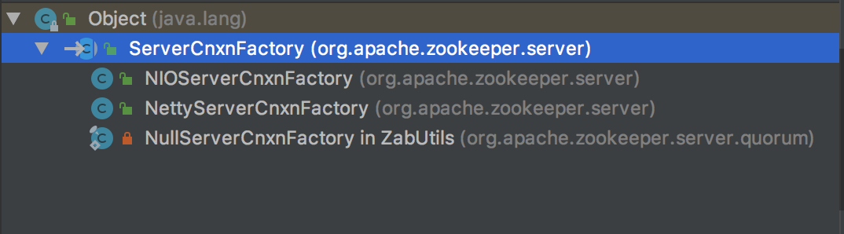

### 3.6.1 startup

有两个启动方法，一个两参的抽象方法，最终都是调用两参的抽象方法

|  |
| --- |
| //  public void startup(ZooKeeperServer zkServer) throws IOException, InterruptedException {  // 调用两参的方法，  startup(zkServer, true); }  // This method is to maintain compatiblity of startup(zks) and enable sharing of zks // when we add secureCnxnFactory. public abstract void startup(ZooKeeperServer zkServer, boolean startServer)  throws IOException, InterruptedException; |

## 3.7 NIOServerCnxnFactory（NIO）

### 3.7.1 startup(启动类)

|  |
| --- |
| // 启动类  public void startup(ZooKeeperServer zks, boolean startServer)  throws IOException, InterruptedException {  start();  setZooKeeperServer(zks);  if (startServer) {  zks.startdata();  zks.startup();  } } |

### 3.7.2 start

启动线程池、接收线程、连接过去监控线程

|  |
| --- |
| public void start() {  stopped = false;  if (workerPool == null) {  // 初始化线程池  // numWorkerThreads工作线程的数量，可配置，没有配置，  // 是cpu核数的两倍  workerPool = new WorkerService(  "NIOWorker", numWorkerThreads, false);  }  // 循环启动selector线程  for(SelectorThread thread : selectorThreads) {  if (thread.getState() == Thread.State.*NEW*) {  thread.start();  }  }  // ensure thread is started once and only once  // 确保线程仅且启动一次  // 接收线程启动  if (acceptThread.getState() == Thread.State.*NEW*) {  acceptThread.start();  }  // 连接过期的监控线程启动  if (expirerThread.getState() == Thread.State.*NEW*) {  expirerThread.start();  } } |

## 3.8 NettyServerCnxnFactory

## 3.9 ZooKeeperThread (zk线程)

继承至Thread，

主要方法就是个处理异常的方法。

|  |
| --- |
| protected void handleException(String thName, Throwable e) {  *LOG*.warn("Exception occurred from thread {}", thName, e); } |

## 3.10 WorkerService(zk线程池)

## 3.11 SessionTrackerImpl(会话管理器，是个线程)

### 3.11.1 类结构

ZooKeeperCriticalThread是ZooKeeperThread的子类，说明这个会话是个线程

|  |
| --- |
| public class SessionTrackerImpl extends ZooKeeperCriticalThread implements  SessionTracker {  } |

### 3.11.2 内部类

SessionTracker中的会话类

|  |
| --- |
| public static interface Session {  // 会话id  long getSessionId();  // 超时时间  int getTimeout();  // 会话是否关闭  boolean isClosing(); } |

子类中的Session实现

|  |
| --- |
| public static class SessionImpl implements Session {  SessionImpl(long sessionId, int timeout) {  this.sessionId = sessionId;  this.timeout = timeout;  isClosing = false;  }   final long sessionId;  final int timeout;  boolean isClosing;   Object owner;   public long getSessionId() { return sessionId; }  public int getTimeout() { return timeout; }  public boolean isClosing() { return isClosing; }   public String toString() {  return "0x" + Long.*toHexString*(sessionId);  } } |

### 3.11.3 主要属性

|  |
| --- |
| // 维护sessionId和session实体映射关系的  protected final ConcurrentHashMap<Long, SessionImpl> sessionsById =  new ConcurrentHashMap<Long, SessionImpl>();  // 过期的会话对象实例对列 private final ExpiryQueue<SessionImpl> sessionExpiryQueue;  // 维护sessionId和过期时间的集合，这个会被定期持久化到快照文件中 private final ConcurrentMap<Long, Integer> sessionsWithTimeout;  // 会话的ID private final AtomicLong nextSessionId = new AtomicLong(); |

### 3.11.4 SessionTrackerImpl的构造函数

|  |
| --- |
| public SessionTrackerImpl(SessionExpirer expirer,  ConcurrentMap<Long, Integer> sessionsWithTimeout, int tickTime,  long serverId, ZooKeeperServerListener listener) {  super("SessionTracker", listener);  this.expirer = expirer;  // tickTime是下次会话超时的时间  // 根据分桶策略维护的会话过期的对列  this.sessionExpiryQueue = new ExpiryQueue<SessionImpl>(tickTime);  this.sessionsWithTimeout = sessionsWithTimeout;  // 初始话SessionId  this.nextSessionId.set(*initializeNextSession*(serverId));  for (Entry<Long, Integer> e : sessionsWithTimeout.entrySet()) {  addSession(e.getKey(), e.getValue());  }   EphemeralType.*validateServerId*(serverId); }  搞8位是服务器serverId，紧接着55位是时间戳，低两位是0  这个sessionId是全局唯一的  public static long initializeNextSession(long id) {  long nextSid;  nextSid = (Time.*currentElapsedTime*() << 24) >>> 8;  nextSid = nextSid | (id << 56);  if (nextSid == EphemeralType.*CONTAINER_EPHEMERAL_OWNER*) {  ++nextSid; // this is an unlikely edge case, but check it just in case  }  return nextSid; }  public synchronized boolean addSession(long id, int sessionTimeout) {  sessionsWithTimeout.put(id, sessionTimeout);   boolean added = false;   SessionImpl session = sessionsById.get(id);  if (session == null) {  实例化session  session = new SessionImpl(id, sessionTimeout);  }   // findbugs2.0.3 complains about get after put.  // long term strategy would be use computeIfAbsent after JDK 1.8  SessionImpl existedSession = sessionsById.putIfAbsent(id, session);   if (existedSession != null) {  session = existedSession;  } else {  added = true;  *LOG*.debug("Adding session 0x" + Long.*toHexString*(id));  }   if (*LOG*.isTraceEnabled()) {  String actionStr = added ? "Adding" : "Existing";  ZooTrace.*logTraceMessage*(*LOG*, ZooTrace.*SESSION_TRACE_MASK*,  "SessionTrackerImpl --- " + actionStr + " session 0x"  + Long.*toHexString*(id) + " " + sessionTimeout);  }   updateSessionExpiry(session, sessionTimeout);  return added; }  // 修改每个会话的过期时间  private void updateSessionExpiry(SessionImpl s, int timeout) {  logTraceTouchSession(s.sessionId, timeout, "");  sessionExpiryQueue.update(s, timeout); } |

### 3.11.5 run方法

|  |
| --- |
| public void run() {  try {  while (running) {  // 计算会话等待时间  long waitTime = sessionExpiryQueue.getWaitTime();  if (waitTime > 0) {  Thread.*sleep*(waitTime);  continue;  }  // 如果会话超时，进行对会话的清除工作  for (SessionImpl s : sessionExpiryQueue.poll()) {  setSessionClosing(s.sessionId);  // expirer就是ZooKeeperServer实例  expirer.expire(s);  }  }  } catch (InterruptedException e) {  handleException(this.getName(), e);  }  *LOG*.info("SessionTrackerImpl exited loop!"); }  synchronized public void setSessionClosing(long sessionId) {  if (*LOG*.isTraceEnabled()) {  *LOG*.trace("Session closing: 0x" + Long.*toHexString*(sessionId));  }  SessionImpl s = sessionsById.get(sessionId);  if (s == null) {  return;  }  // 将session的关闭标志设置成true  s.isClosing = true; } |

## 3.12 ExpiryQueue(过期会话对列)

这个主要是根据“分桶策略”进行对 同一时间段内过期的会话进行管理

### 3.12.1 主要属性

|  |
| --- |
| */**  * The maximum number of buckets is equal to max timeout/expirationInterval,  * so the expirationInterval should not be too small compared to the  * max timeout that this expiry queue needs to maintain.  */*  *// 时间戳为key，会话实体的set集合为value，* private final ConcurrentHashMap<Long, Set<E>> expiryMap =  new ConcurrentHashMap<Long, Set<E>>();  private final AtomicLong nextExpirationTime = new AtomicLong();  // 这个值就是tickTime，也就是会话的下次连接时间 private final int expirationInterval; |

## 3.13 ServerCnxn(服务端连接管理类)

代表一个从客户端到服务端连接

### 3.13.1 属性

|  |
| --- |
| // 认证信息  protected ArrayList<Id> authInfo = new ArrayList<Id>();  private static final byte[] *fourBytes* = new byte[4];  */**  * If the client is of old version, we don't send r-o mode info to it.  * The reason is that if we would, old C client doesn't read it, which  * results in TCP RST packet, i.e. "connection reset by peer".  */*  *// 是否是旧客户端* boolean isOldClient = true;  // 一下主要是描述连接的统计信息  // 连接创建时间  protected final Date established = new Date(); // 接收的数据包数量 protected final AtomicLong packetsReceived = new AtomicLong();  // 发送的数据包数量 protected final AtomicLong packetsSent = new AtomicLong();  // 最小延迟 protected long minLatency;  // 最大延迟 protected long maxLatency;  // 最后的操作 protected String lastOp;  // 最后的cxid protected long lastCxid;  // 最后的zxid protected long lastZxid;  // 最后的响应时间 protected long lastResponseTime;  // 最后的延迟 protected long lastLatency; // 数量 protected long count;  // 总的延迟 protected long totalLatency; |

## 3.14 Watcher

定义了一事件(事件类型和zookeeper状态)和watcherType

## 3.15 RequestProcessor（请求处理器）

该类比较多，zookeeperServer服务启动的时候，请求处理链的第一个类是PreRequestProcessor

### 3.15.1 PreRequestProcessor(第一个处理器)

### 3.15.2 SyncRequestProcessor

### 3.15.3 FinalRequestProcessor(最后一个处理器)

所有的请求或查询服务都会经过这个处理器，这个处理器会对zookeeperServer的outstandingRequests进行计数统计

## 3.16 ZKDatabase

zookeeper服务器状态的内存数据库，包括session、datatree和提交的事务日志。

当重启时，会重日志和快照中读取数据，加载恢复

|  |
| --- |
| */**  * This class maintains the in memory database of zookeeper  * server states that includes the sessions, datatree and the  * committed logs. It is booted up after reading the logs  * and snapshots from the disk.  */* public class ZKDatabase {  } |

### 3.16.1 主要属性

|  |
| --- |
| // 节点数据对象  protected DataTree dataTree;  // 持久化到快照中的session对应的过期时间的映射关系集合 protected ConcurrentHashMap<Long, Integer> sessionsWithTimeouts;  // 快照和事务日志对象 protected FileTxnSnapLog snapLog;  // 最小提交的日志，最大提交的日志 protected long minCommittedLog, maxCommittedLog;  */**  * Default value is to use snapshot if txnlog size exceeds 1/3 the size of snapshot  */*  *//* public static final String *SNAPSHOT_SIZE_FACTOR* = "zookeeper.snapshotSizeFactor"; public static final double *DEFAULT_SNAPSHOT_SIZE_FACTOR* = 0.33; private double snapshotSizeFactor;  public static final int *commitLogCount* = 500; protected static int *commitLogBuffer* = 700; protected LinkedList<Proposal> committedLog = new LinkedList<Proposal>();  // 日志文件的读写锁 protected ReentrantReadWriteLock logLock = new ReentrantReadWriteLock(); volatile private boolean initialized = false; |

## 3.20 FileTxnSnapSnapLog(辅助类：事务日志和快照)

主要作用将最新的事务日志和快照文件再重启动的过程中，重新加载，并且反序列化出文件的内容。用于获取session等信息

## 3.21 FileTxnLog(事务日志的文件类)

## 3.22 FileSnap(快照的文件类)

## 3.23 ZooKeeper (客户端连接启动类）

### 3.23.1 主要字段

|  |
| --- |
| // 负责解析服务器地址配置的类  protected final HostProvider hostProvider;  // 管理注册到服务器的Watcher  protected final ZKWatchManager watchManager; // 客户端的配置文件类 private final ZKClientConfig clientConfig; |

### 3.23.2 内部类

|  |
| --- |
| // 管理watchers、处理ClientCnxn(客户端连接类)产生的事件  static class ZKWatchManager implements ClientWatchManager {  // 数据监听器  private final Map<String, Set<Watcher>> dataWatches =  new HashMap<String, Set<Watcher>>();  // 特殊监听器 private final Map<String, Set<Watcher>> existWatches =  new HashMap<String, Set<Watcher>>();  // 子结点监听器 private final Map<String, Set<Watcher>> childWatches =  new HashMap<String, Set<Watcher>>();  }  // Watcher的注册器：将一个Watcher注册到一个特殊的路径下  public abstract class WatchRegistration {  }  // 处理已存在的特殊的watches  // 这种情形一般是无节点结果码值返回  class ExistsWatchRegistration extends WatchRegistration {  public ExistsWatchRegistration(Watcher watcher, String clientPath) {  super(watcher, clientPath);  }   @Override  protected Map<String, Set<Watcher>> getWatches(int rc) {  return rc == 0 ? watchManager.dataWatches : watchManager.existWatches;  }   @Override  protected boolean shouldAddWatch(int rc) {  return rc == 0 || rc == KeeperException.Code.*NONODE*.intValue();  } }  @Override protected boolean shouldAddWatch(int rc) {  return rc == 0 || rc == KeeperException.Code.*NONODE*.intValue(); }  }  //和上面类似的注册器：这是个节点数据的注册器  class DataWatchRegistration extends WatchRegistration {  public DataWatchRegistration(Watcher watcher, String clientPath) {  super(watcher, clientPath);  }   @Override  protected Map<String, Set<Watcher>> getWatches(int rc) {  return watchManager.dataWatches;  } }  // 子节点的Watches注册器  class ChildWatchRegistration extends WatchRegistration {  public ChildWatchRegistration(Watcher watcher, String clientPath) {  super(watcher, clientPath);  }   @Override  protected Map<String, Set<Watcher>> getWatches(int rc) {  return watchManager.childWatches;  } } |

### 3.23.3 构造函数

有好些构造函数，但最终都是调用的下面这个

connectString:服务端连接地址

sessionTimeout：会话超时时间

watcher：监听器watcher

canBeReadOnly：是否仅读模式

aHostProvider：ip地址解析的提供者

clientConfig：客户端配置

|  |
| --- |
| public ZooKeeper(String connectString, int sessionTimeout, Watcher watcher,  boolean canBeReadOnly, HostProvider aHostProvider,  ZKClientConfig clientConfig) throws IOException {  *LOG*.info("Initiating client connection, connectString=" + connectString  + " sessionTimeout=" + sessionTimeout + " watcher=" + watcher);   if (clientConfig == null) {  // 创建配置类  clientConfig = new ZKClientConfig();  }  this.clientConfig = clientConfig;  // 实例化watch管理器，  watchManager = defaultWatchManager();  // 管理器设置默认的Watcher  watchManager.defaultWatcher = watcher;  // 连接解析器  ConnectStringParser connectStringParser = new ConnectStringParser(  connectString);  // 这个实在上一个构造器中传过来的  // 通过调用createDefaultHostProvider方法进行创建的  // StaticHostProvider  hostProvider = aHostProvider;  // 连接管理：发送请求，接收响应等等  // getClientCnxnSocket()是获得一个底层处理socket IO的实现类  // 分别是ClientCnxnSocketNIO和ClientCnxnSocketNetty  // 默认是使用ClientCnxnSocketNIO，最终这个实例会传给SendThread  cnxn = createConnection(connectStringParser.getChrootPath(),  hostProvider, sessionTimeout, this, watchManager,  getClientCnxnSocket(), canBeReadOnly);  // 启动连接线程  cnxn.start(); }  protected ZKWatchManager defaultWatchManager() {  return new ZKWatchManager(getClientConfig().getBoolean(ZKClientConfig.*DISABLE_AUTO_WATCH_RESET*)); }  private static HostProvider createDefaultHostProvider(String connectString) {  return new StaticHostProvider(  new ConnectStringParser(connectString).getServerAddresses()); } |

## 3.24 ZKClientConfig (客户端配置)

继承至ZKConfig，在这个父类中有properties属性HashMap字段，解析的配置值都放在这个map中了。就不详细展开了，这个类其实和服务端的QuorumPeerConfig作用类似，有些区别，这个是用map装了很多属性，QuorumPeerConfig是针对每个配置定义了一个字段。

## 3.25 ClientCnxn (客户端连接器)

ZooKeeper启动类，启动的就是这个类。这个类是管理客户端的socket IO。

### 3.25.1 主要属性

|  |
| --- |
| /* ZOOKEEPER-706: If a session has a large number of watches set then  * attempting to re-establish those watches after a connection loss may  * fail due to the SetWatches request exceeding the server's configured  * jute.maxBuffer value. To avoid this we instead split the watch  * re-establishement across multiple SetWatches calls. This constant  * controls the size of each call. It is set to 128kB to be conservative  * with respect to the server's 1MB default for jute.maxBuffer.  */ private static final int *SET_WATCHES_MAX_LENGTH* = 128 * 1024;  // 权限验证信息包装类 static class AuthData {  AuthData(String scheme, byte data[]) {  this.scheme = scheme;  this.data = data;  }   String scheme;   byte data[]; }  // 认证信息集合 private final CopyOnWriteArraySet<AuthData> authInfo = new CopyOnWriteArraySet<AuthData>();  */**  * These are the packets that have been sent and are waiting for a response.  */*  *// 已经发送的请求数据包的集合，处于等待响应中* private final LinkedList<Packet> pendingQueue = new LinkedList<Packet>();  */**  * These are the packets that need to be sent.  */*  *// 待发送的数据包集合* private final LinkedBlockingDeque<Packet> outgoingQueue = new LinkedBlockingDeque<Packet>();  // 连接超时时间 private int connectTimeout;  */**  * The timeout in ms the client negotiated with the server. This is the  * "real" timeout, not the timeout request by the client (which may have  * been increased/decreased by the server which applies bounds to this  * value.  */* private volatile int negotiatedSessionTimeout;  // 读超时 private int readTimeout;  // 会话超时 private final int sessionTimeout;  private final ZooKeeper zooKeeper;  private final ClientWatchManager watcher; // 会话id private long sessionId;  // 会话的密码 private byte sessionPasswd[] = new byte[16];  */**  * If true, the connection is allowed to go to r-o mode. This field's value  * is sent, besides other data, during session creation handshake. If the  * server on the other side of the wire is partitioned it'll accept  * read-only clients only.  */* private boolean readOnly;  final String chrootPath;  // 发送线程 final SendThread sendThread;  // 时间监听的响应线程 final EventThread eventThread;  */**  * Set to true when close is called. Latches the connection such that we  * don't attempt to re-connect to the server if in the middle of closing the  * connection (client sends session disconnect to server as part of close  * operation)  */* private volatile boolean closing = false;  *// 服务器集群地址提供者* private final HostProvider hostProvider;  // volatile boolean seenRwServerBefore = false;  //  public ZooKeeperSaslClient zooKeeperSaslClient;  // 配置 private final ZKClientConfig clientConfig; */**  * If any request's response in not received in configured requestTimeout  * then it is assumed that the response packet is lost.  */*  *// 请求超时时间* private long requestTimeout; |

### 3.25.2 start方法

启动，实际上是是启动了发送线程和事件响应线程

这两个线程均是内部类

|  |
| --- |
| public void start() {  sendThread.start();  eventThread.start(); } |

### 3.25.3 内部类SendThead(发送线程)

继承至ZookeeperThread，服务于待发送的请求，已经发送心跳检测

**3.25.3.1 字段**

|  |
| --- |
| // 心跳  private long lastPingSentNs;  // Socket连接 private final ClientCnxnSocket clientCnxnSocket; private Random r = new Random();  // 是否首次连接 private boolean isFirstConnect = true; |

**3.25.3.2 run方法**

|  |
| --- |
| public void run() {  // 为sendTread，sessionId，outgoingQueue三字段赋值  clientCnxnSocket.introduce(this, sessionId, outgoingQueue);  // Time.*currentElapsedTime*(),就是当前时间，毫秒  clientCnxnSocket.updateNow();  // 更新上次发送的时间戳和心跳的时间戳  clientCnxnSocket.updateLastSendAndHeard();  int to;  // 最后一次ping服务器的时间  long lastPingRwServer = Time.*currentElapsedTime*();  // 最大发送ping的时间间隔  final int MAX_SEND_PING_INTERVAL = 10000; //10 seconds  InetSocketAddress serverAddress = null;  // 连接还存活，就一直会运行下去，存活的条件是：只要不是连接关闭且认证失败的  // 状态  while (state.isAlive()) {  try {  // socket 是否还在连接着，  if (!clientCnxnSocket.isConnected()) {  // 这里执行不连接的逻辑  // don't re-establish connection if we are closing  // 如果正在关闭客户端，则跳出循环  if (closing) {  break;  }  // zookeeper服务端的地址  if (rwServerAddress != null) {  serverAddress = rwServerAddress;  rwServerAddress = null;  } else {  serverAddress = hostProvider.next(1000);  }  // 没有连接开始启动连接  startConnect(serverAddress);  // socket更新最后一次发送和心跳时间  clientCnxnSocket.updateLastSendAndHeard();  }  // 客户端还处在连接状态中  if (state.isConnected()) {  // determine whether we need to send an AuthFailed event.  // 判断是否还需要认证  if (zooKeeperSaslClient != null) {  boolean sendAuthEvent = false;  if (zooKeeperSaslClient.getSaslState() == ZooKeeperSaslClient.SaslState.*INITIAL*) {  try {  zooKeeperSaslClient.initialize(ClientCnxn.this);  } catch (SaslException e) {  *LOG*.error("SASL authentication with Zookeeper Quorum member failed: " + e);  state = States.*AUTH_FAILED*;  sendAuthEvent = true;  }  }  KeeperState authState = zooKeeperSaslClient.getKeeperState();  if (authState != null) {  if (authState == KeeperState.*AuthFailed*) {  // An authentication error occurred during authentication with the Zookeeper Server.  // 认证失败，把状态修改为认证失败  state = States.*AUTH_FAILED*;  sendAuthEvent = true;  } else {  if (authState == KeeperState.*SaslAuthenticated*) {  sendAuthEvent = true;  }  }  }  // 认证成功后，  if (sendAuthEvent) {  // 在事件处理线程的等待对列中添加一个需要被触发的  // 事件类型  eventThread.queueEvent(new WatchedEvent(  Watcher.Event.EventType.*None*,  authState,null));  if (state == States.*AUTH_FAILED*) {  eventThread.queueEventOfDeath();  }  }  }  // 读超时时间减去(上次心跳到这次连接的时间差)  to = readTimeout - clientCnxnSocket.getIdleRecv();  } else {  // 连接超时时间减去(上次心跳到这次连接的时间差)  to = connectTimeout - clientCnxnSocket.getIdleRecv();  }  // to目的是为了判断连接是否超时了  if (to <= 0) {  // 说明会话超时了  String warnInfo;  warnInfo = "Client session timed out, have not heard from server in "  + clientCnxnSocket.getIdleRecv()  + "ms"  + " for sessionid 0x"  + Long.*toHexString*(sessionId);  *LOG*.warn(warnInfo);  throw new SessionTimeoutException(warnInfo);  }  //   if (state.isConnected()) {  //1000(1 second) is to prevent race condition missing to send the second ping  //also make sure not to send too many pings when readTimeout is small  // 计算下次Ping的时间  int timeToNextPing = readTimeout / 2 - clientCnxnSocket.getIdleSend() -   ((clientCnxnSocket.getIdleSend() > 1000) ? 1000 : 0);  //send a ping request either time is due or no packet sent out within MAX_SEND_PING_INTERVAL  //   if (timeToNextPing <= 0 || clientCnxnSocket.getIdleSend() > MAX_SEND_PING_INTERVAL) {  sendPing();  clientCnxnSocket.updateLastSend();  } else {  if (timeToNextPing < to) {  to = timeToNextPing;  }  }  }   // If we are in read-only mode, seek for read/write server  if (state == States.*CONNECTEDREADONLY*) {  long now = Time.*currentElapsedTime*();  int idlePingRwServer = (int) (now - lastPingRwServer);  if (idlePingRwServer >= pingRwTimeout) {  lastPingRwServer = now;  idlePingRwServer = 0;  pingRwTimeout =  Math.*min*(2*pingRwTimeout, *maxPingRwTimeout*);  pingRwServer();  }  to = Math.*min*(to, pingRwTimeout - idlePingRwServer);  }   clientCnxnSocket.doTransport(to, pendingQueue, ClientCnxn.this);  } catch (Throwable e) {  if (closing) {  if (*LOG*.isDebugEnabled()) {  // closing so this is expected  *LOG*.debug("An exception was thrown while closing send thread for session 0x"  + Long.*toHexString*(getSessionId())  + " : " + e.getMessage());  }  break;  } else {  // this is ugly, you have a better way speak up  if (e instanceof SessionExpiredException) {  *LOG*.info(e.getMessage() + ", closing socket connection");  } else if (e instanceof SessionTimeoutException) {  *LOG*.info(e.getMessage() + *RETRY_CONN_MSG*);  } else if (e instanceof EndOfStreamException) {  *LOG*.info(e.getMessage() + *RETRY_CONN_MSG*);  } else if (e instanceof RWServerFoundException) {  *LOG*.info(e.getMessage());  } else if (e instanceof SocketException) {  *LOG*.info("Socket error occurred: {}: {}", serverAddress, e.getMessage());  } else {  *LOG*.warn("Session 0x{} for server {}, unexpected error{}",  Long.*toHexString*(getSessionId()),  serverAddress,  *RETRY_CONN_MSG*,  e);  }  // At this point, there might still be new packets appended to outgoingQueue.  // they will be handled in next connection or cleared up if closed.  cleanAndNotifyState();  }  }  }  synchronized (state) {  // When it comes to this point, it guarantees that later queued  // packet to outgoingQueue will be notified of death.  cleanup();  }  clientCnxnSocket.close();  if (state.isAlive()) {  eventThread.queueEvent(new WatchedEvent(Event.EventType.*None*,  Event.KeeperState.*Disconnected*, null));  }  eventThread.queueEvent(new WatchedEvent(Event.EventType.*None*,  Event.KeeperState.*Closed*, null));  ZooTrace.*logTraceMessage*(*LOG*, ZooTrace.*getTextTraceLevel*(),  "SendThread exited loop for session: 0x"  + Long.*toHexString*(getSessionId())); } |

**3.25.3.3 startConnect方法**

启动连接

|  |
| --- |
| private void startConnect(InetSocketAddress addr) throws IOException {  // initializing it for new connection  // sasl登陆失败标志  saslLoginFailed = false;  if(!isFirstConnect){  // 不是首次连接，则线程沉睡0-1s之间的随机时间  try {  Thread.*sleep*(r.nextInt(1000));  } catch (InterruptedException e) {  *LOG*.warn("Unexpected exception", e);  }  }  //ZooKeeper将状态修改为正在连接中  state = States.*CONNECTING*;  // 服务器的地址端口  String hostPort = addr.getHostString() + ":" + addr.getPort();  MDC.*put*("myid", hostPort);  // 设置线程的名称，设置成服务器地址端口  setName(getName().replaceAll("\\(.*\\)", "(" + hostPort + ")"));  if (clientConfig.isSaslClientEnabled()) {  try {  if (zooKeeperSaslClient != null) {  zooKeeperSaslClient.shutdown();  }  zooKeeperSaslClient = new ZooKeeperSaslClient(SaslServerPrincipal.*getServerPrincipal*(addr, clientConfig),  clientConfig);  } catch (LoginException e) {  // An authentication error occurred when the SASL client tried to initialize:  // for Kerberos this means that the client failed to authenticate with the KDC.  // This is different from an authentication error that occurs during communication  // with the Zookeeper server, which is handled below.  *LOG*.warn("SASL configuration failed: " + e + " Will continue connection to Zookeeper server without "  + "SASL authentication, if Zookeeper server allows it.");  eventThread.queueEvent(new WatchedEvent(  Watcher.Event.EventType.*None*,  Watcher.Event.KeeperState.*AuthFailed*, null));  saslLoginFailed = true;  }  }  // 将连接信息输出到日志  logStartConnect(addr);  // socket 连接  clientCnxnSocket.connect(addr); } |

### 3.25.4 内部类EventThead(事件线程)

负责客户端的事件处理，并触发客户端注册的Watcher监听。EventThread中有一个waitingEvents对列，用于临时存放那些需要被触发的Object。包括哪些客户端注册的Watcher和异步接口中注册的回调器AsyncCallback。同时，EventThread会不断地从waitingEvents这个对列中取出Object，识别出其具体类型，并分别调用process和processResult接口方法来实现对事件的触发和回调。

**3.25.4.1 字段**

|  |
| --- |
| // 等待被触发的Object，Watcher或者回调器  private final LinkedBlockingQueue<Object> waitingEvents =  new LinkedBlockingQueue<Object>();  private volatile KeeperState sessionState = KeeperState.*Disconnected*;  private volatile boolean wasKilled = false; private volatile boolean isRunning = false; |

## 3.26 ClientCnxnSocketNIO(客户端处理Socket IO)

# debug-demo

## 4.1 会话建立的demo

|  |
| --- |
| package org.apache.myzookeeper;  import org.apache.zookeeper.WatchedEvent; import org.apache.zookeeper.Watcher; import org.apache.zookeeper.ZooKeeper;  import java.util.concurrent.CountDownLatch;  public class ZookeeperTest1 implements Watcher {   private static CountDownLatch *latch* = new CountDownLatch(1);   public static void main(String[] args) throws Exception {   ZooKeeper zooKeeper = new ZooKeeper("127.0.0.1:2181", 5000, new ZookeeperTest1());  System.*err*.println("client getState = " + zooKeeper.getState());  *latch*.await();  System.*out*.println("zookeeper session established");   }    @Override  public void process(WatchedEvent event) {  System.*err*.println("Receive watched event: " + event);  if (Event.KeeperState.*SyncConnected* == event.getState()) {  *latch*.countDown();  }  } } |